
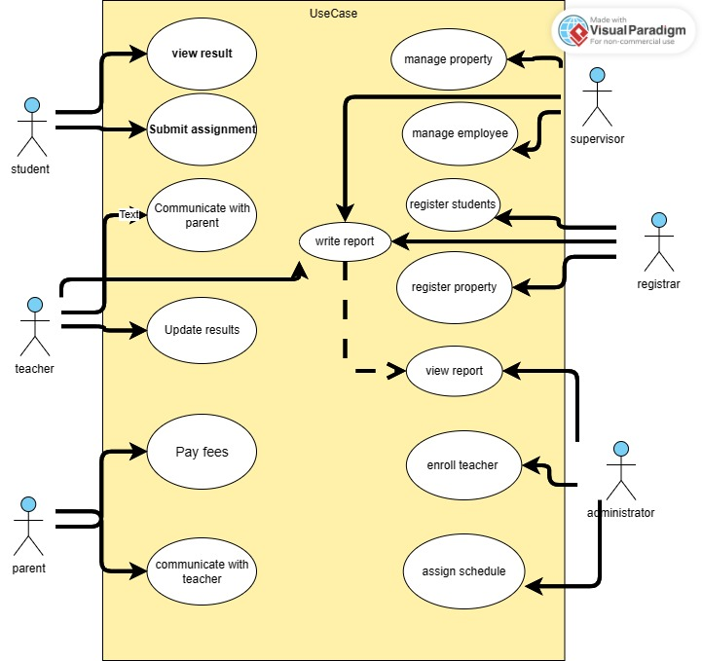
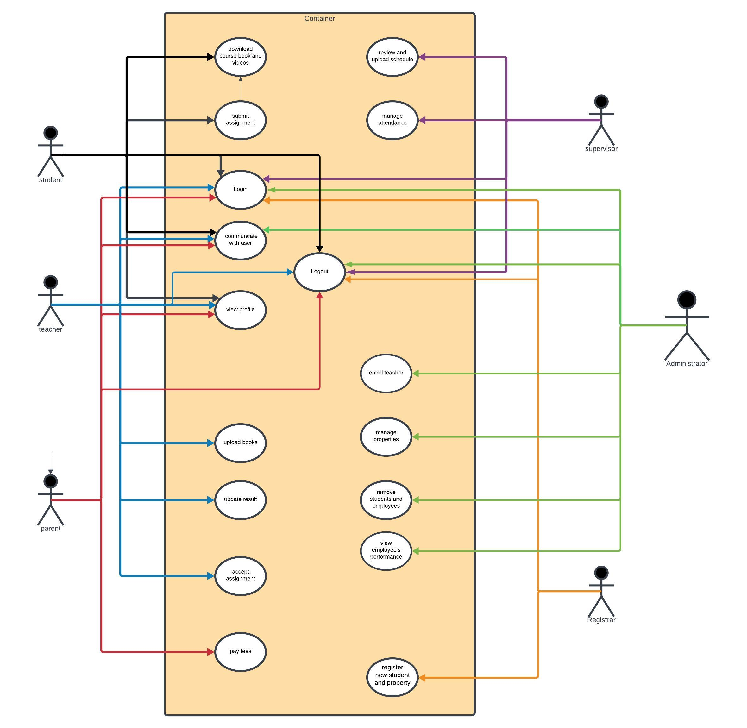
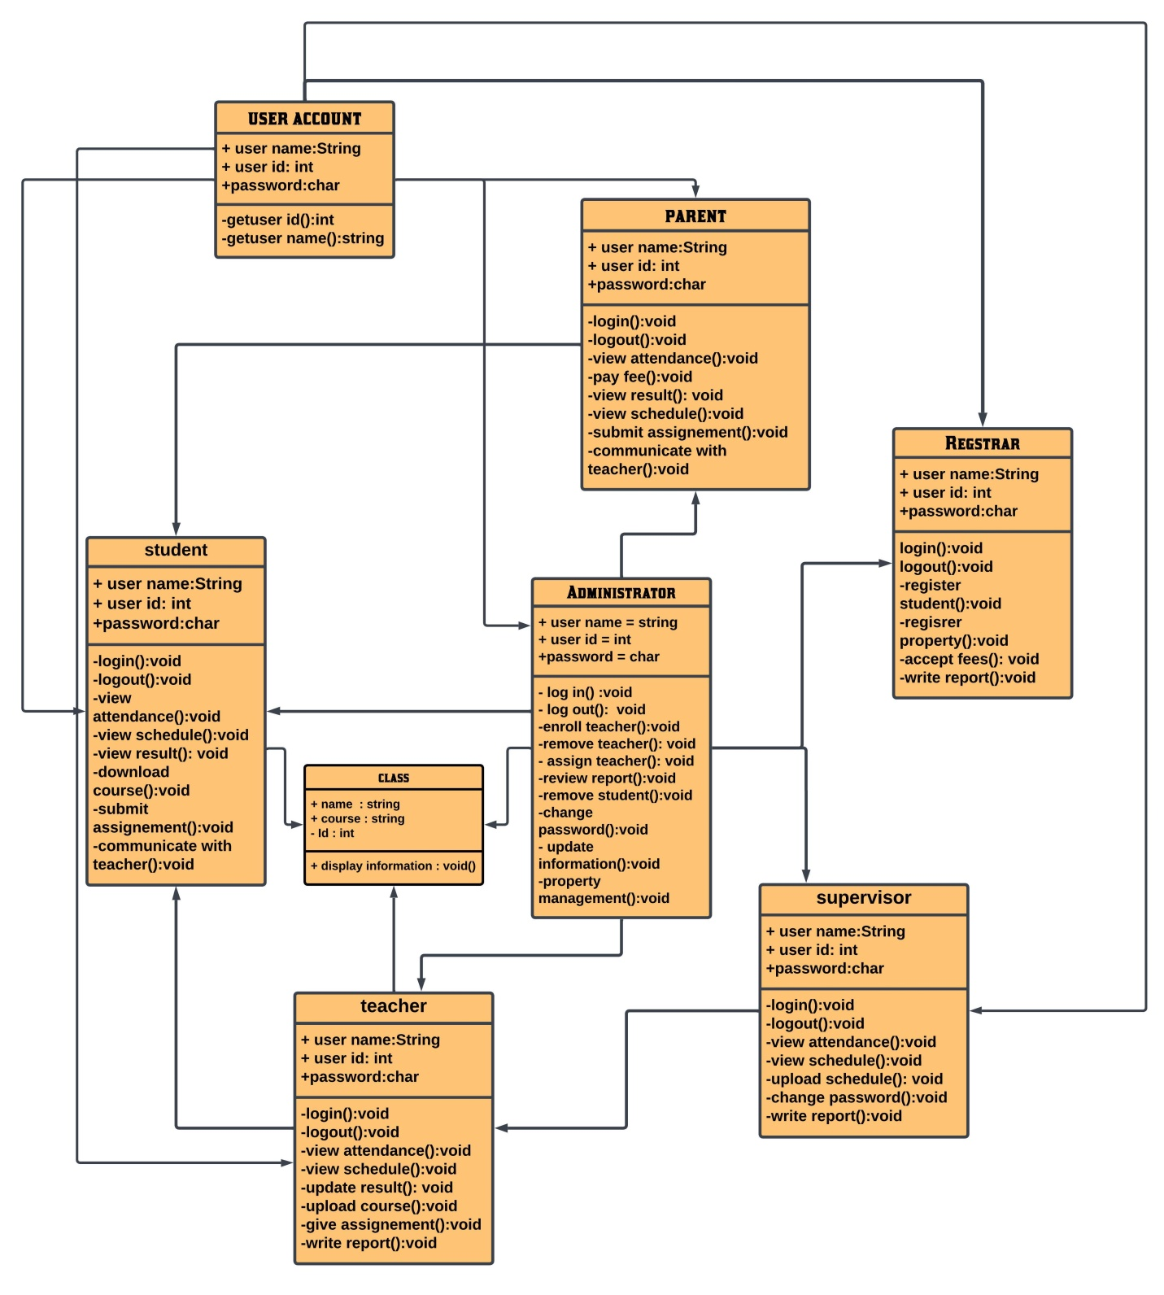
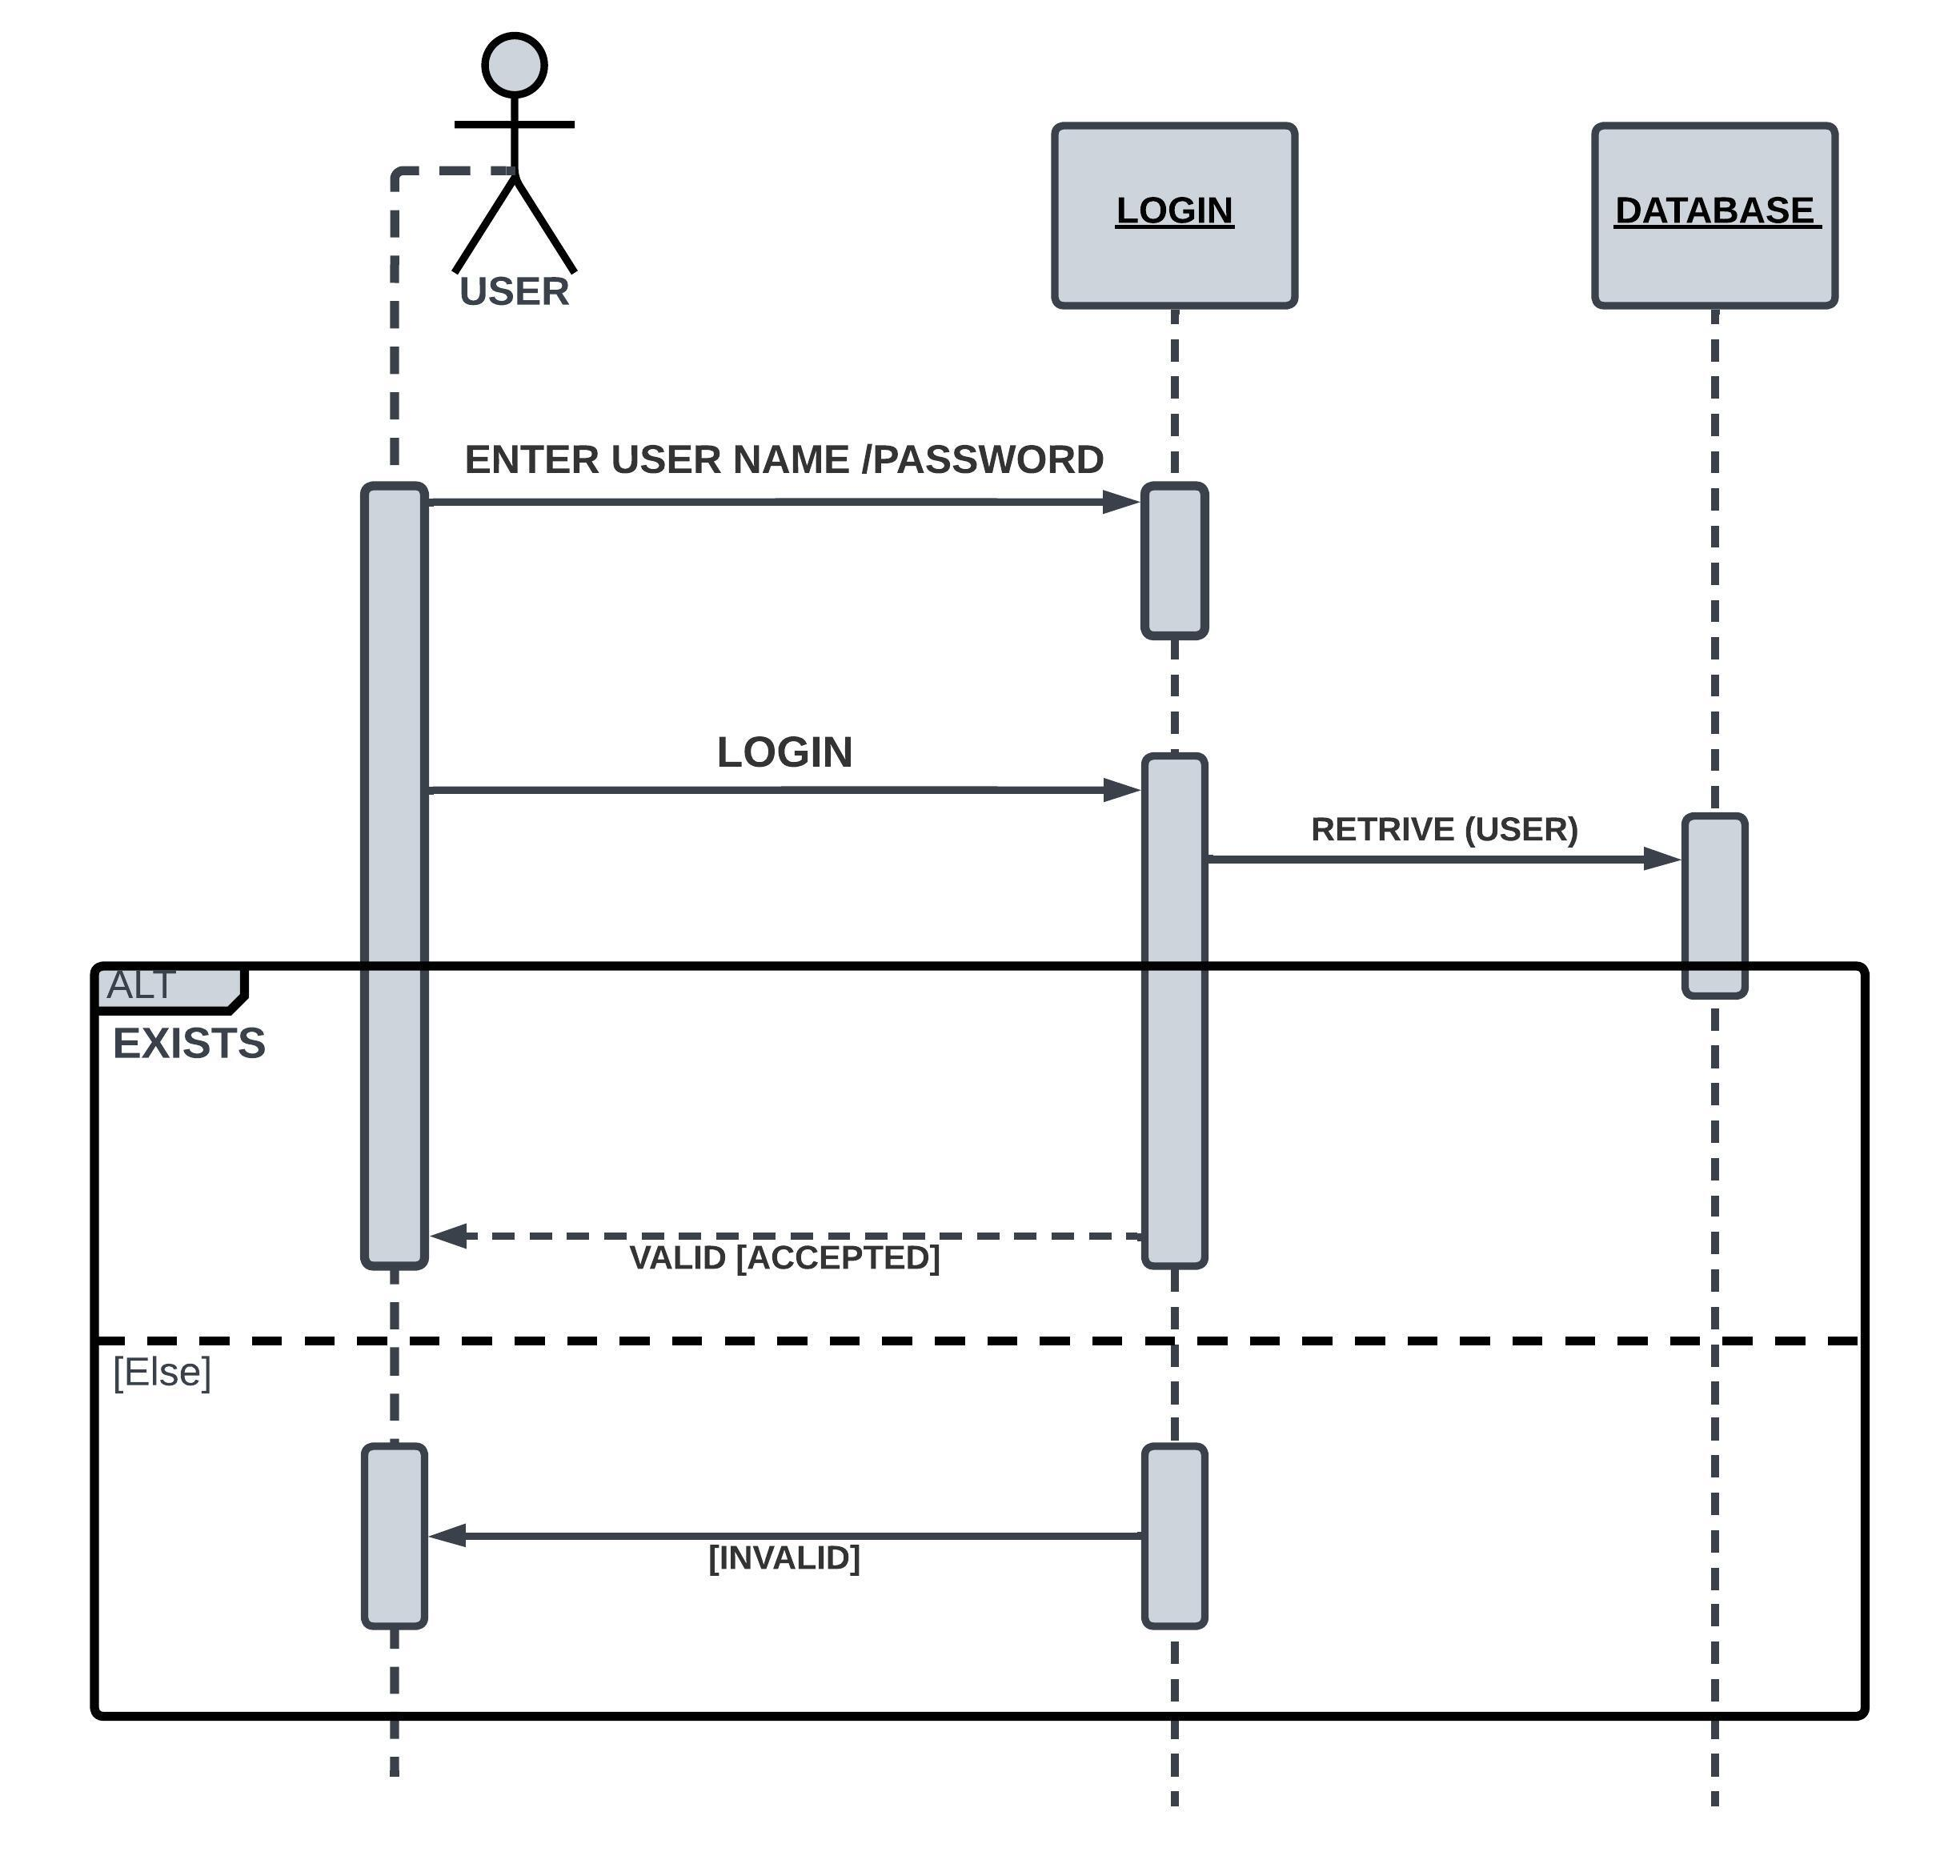
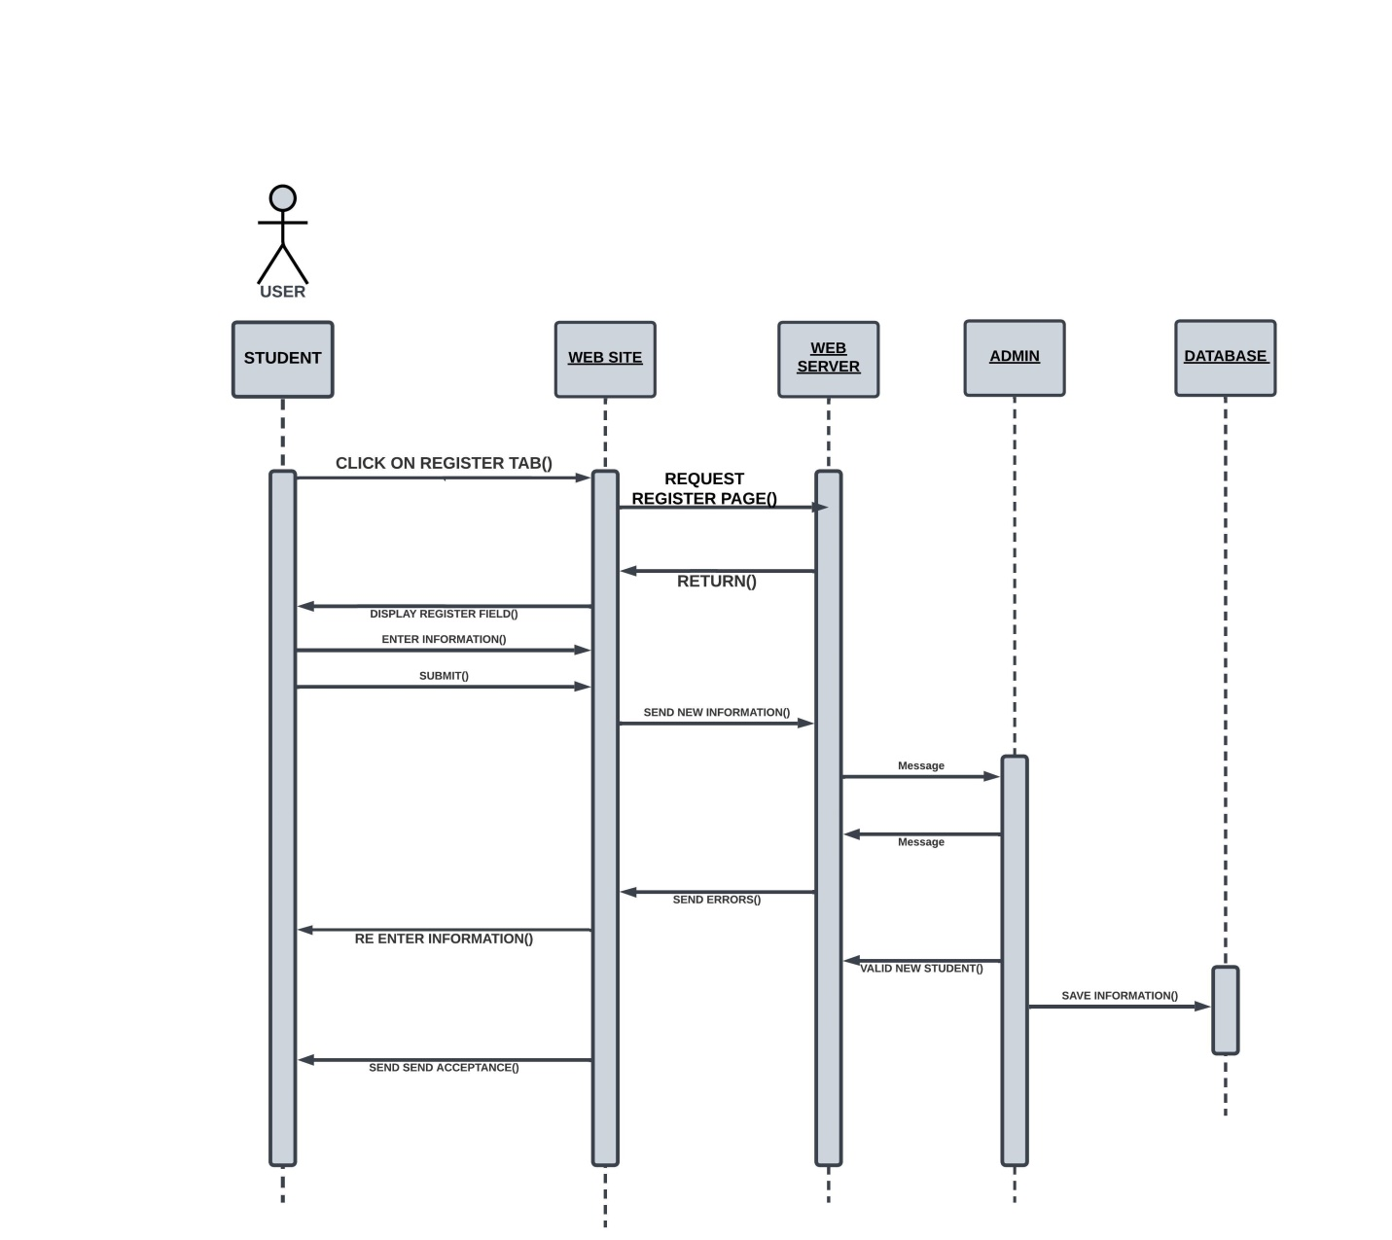
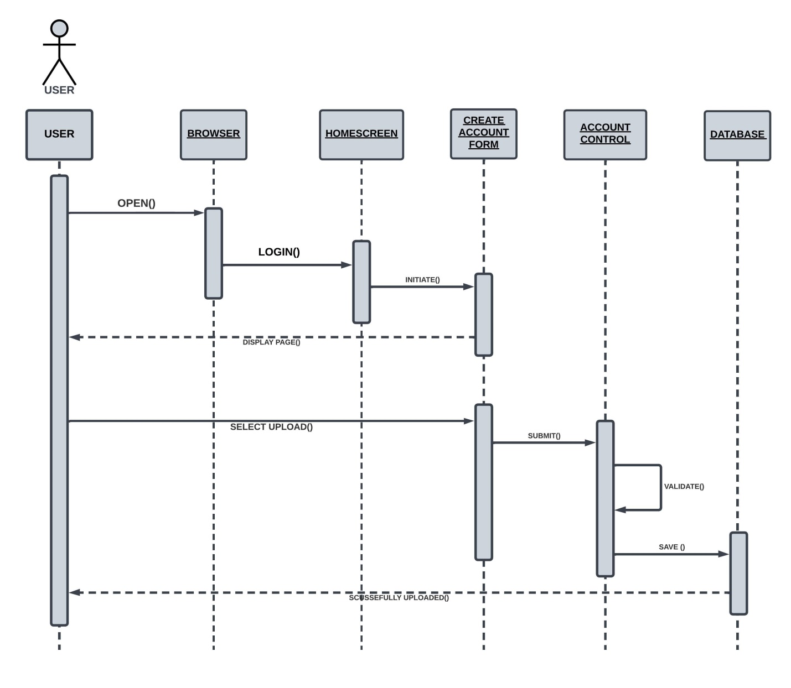
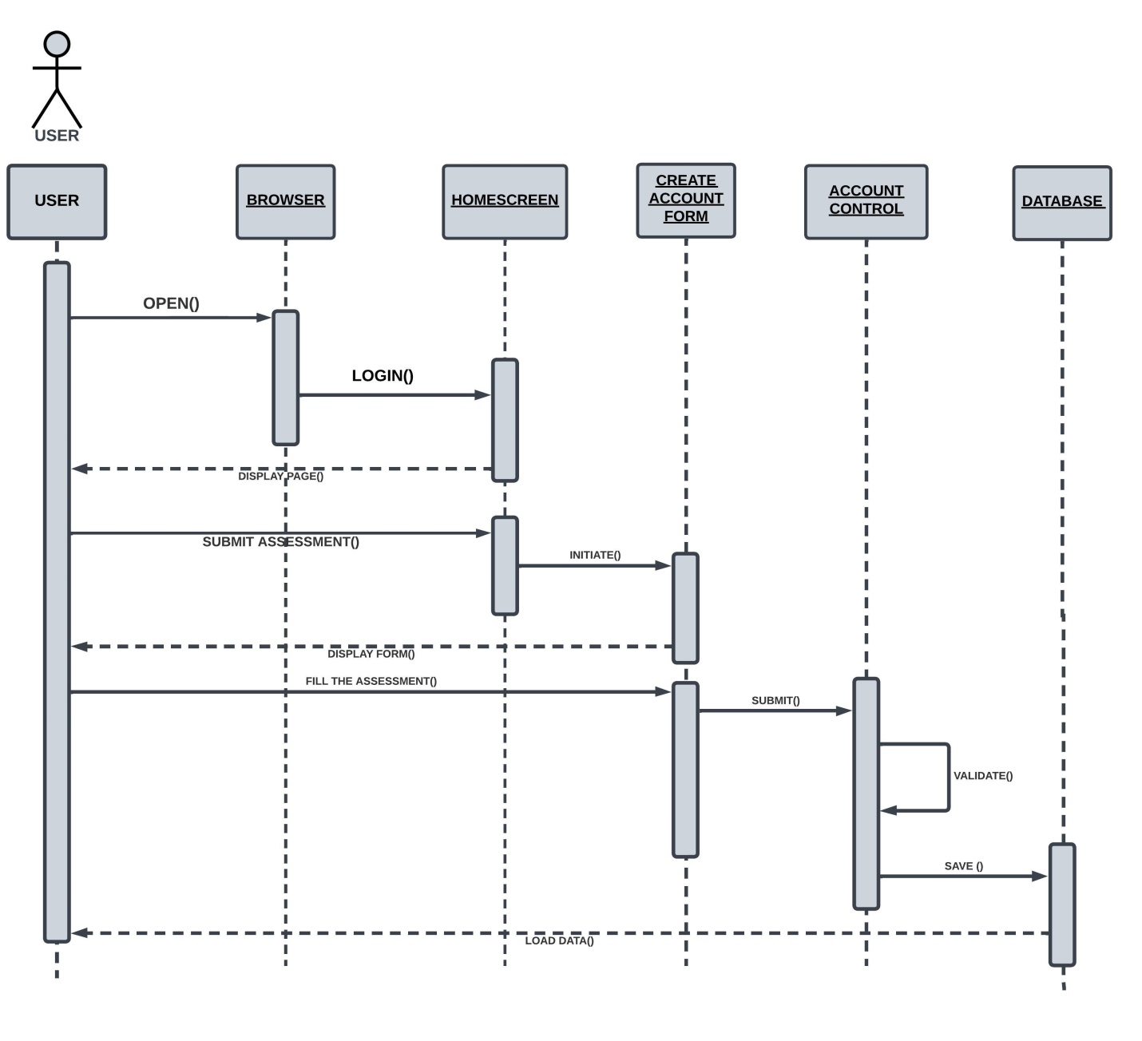
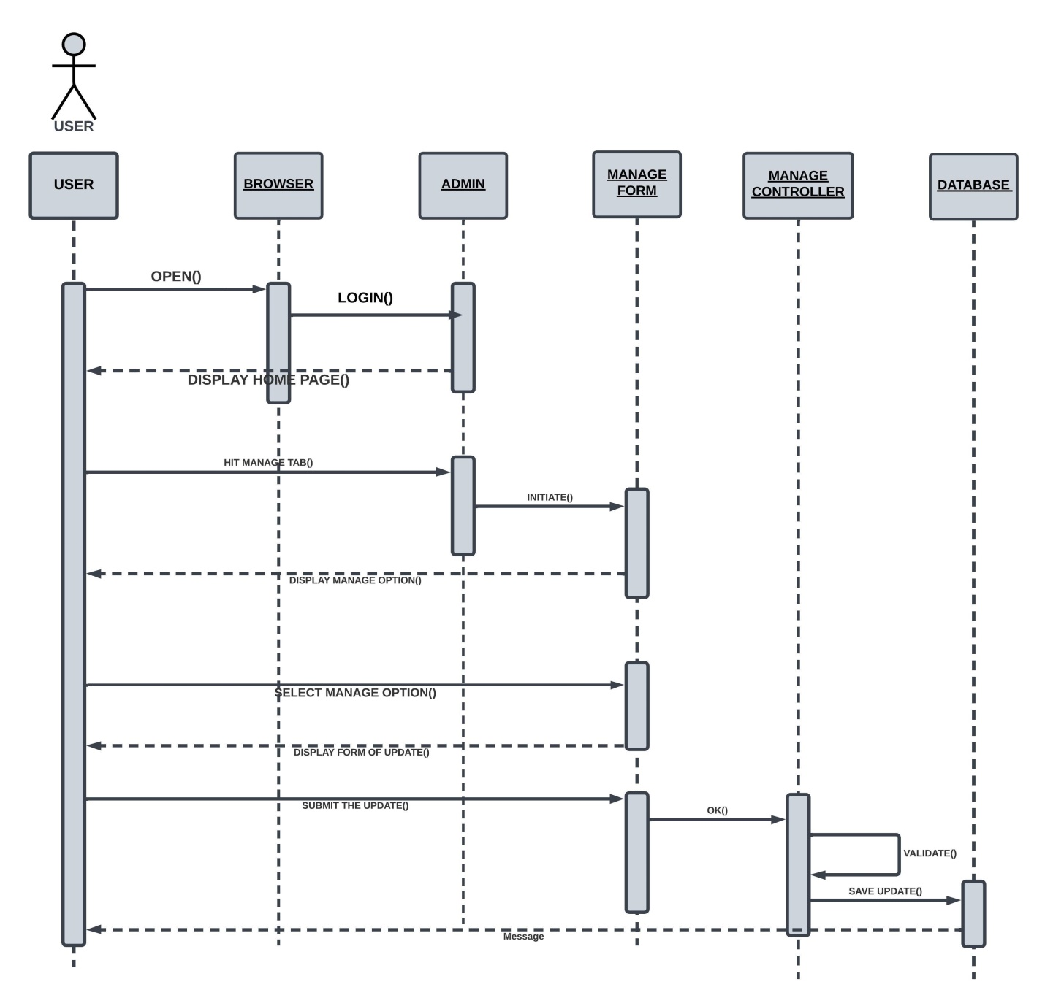
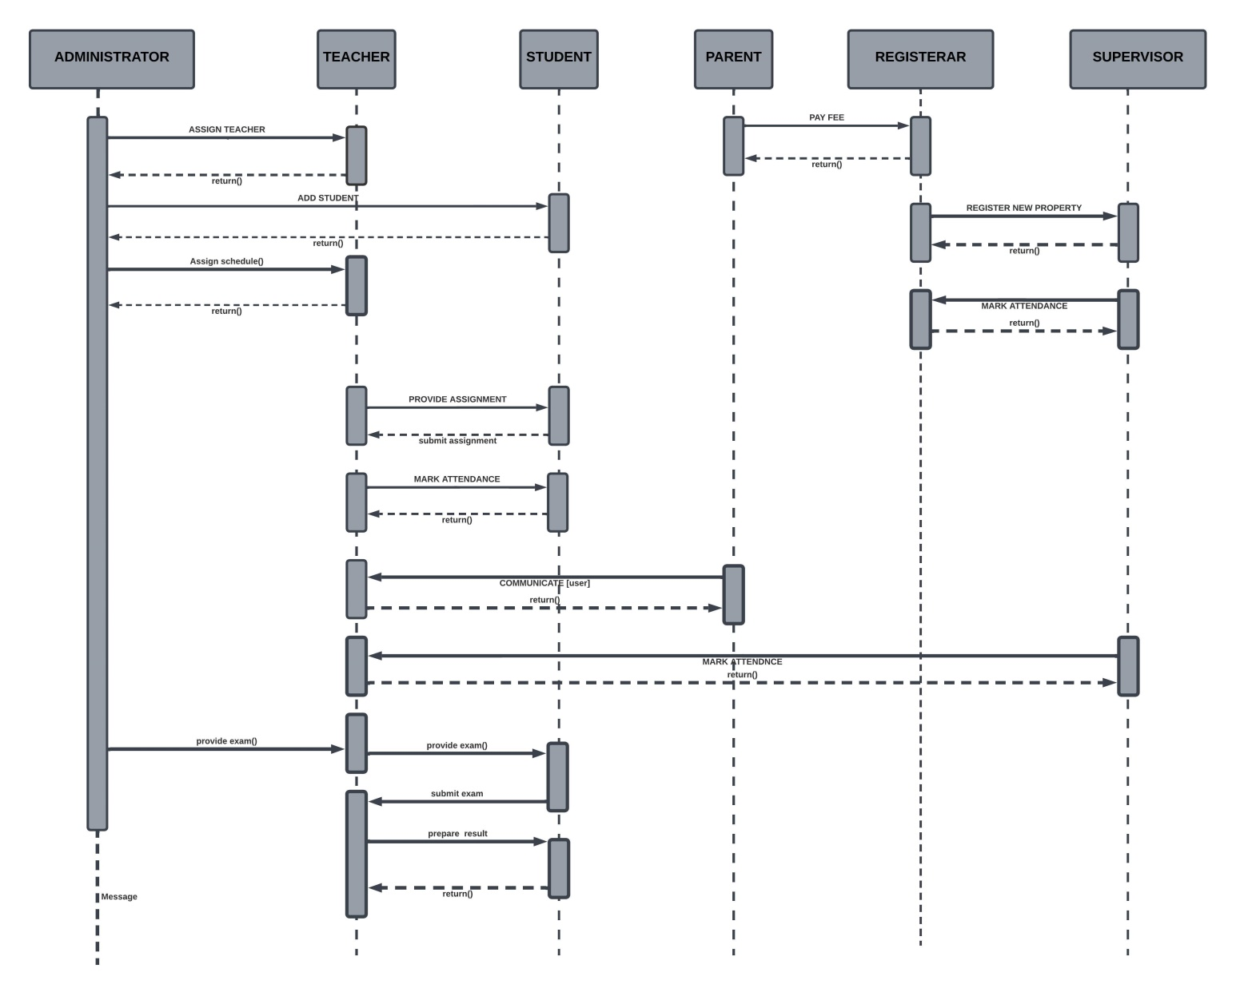
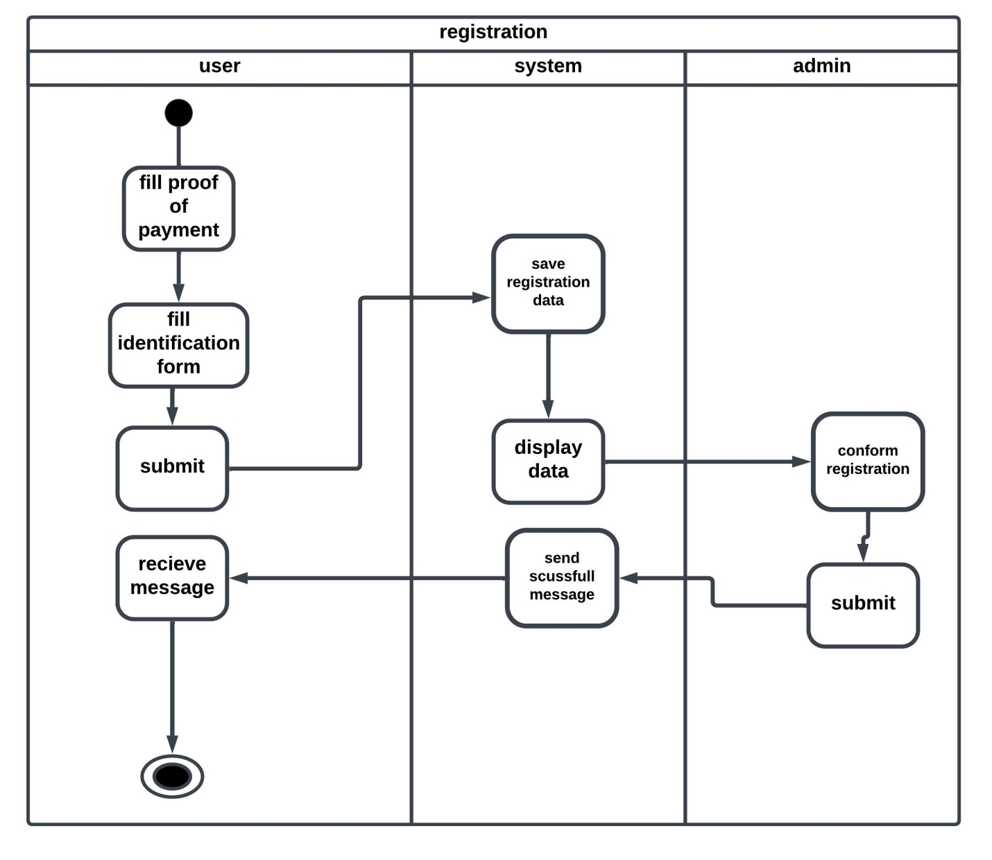
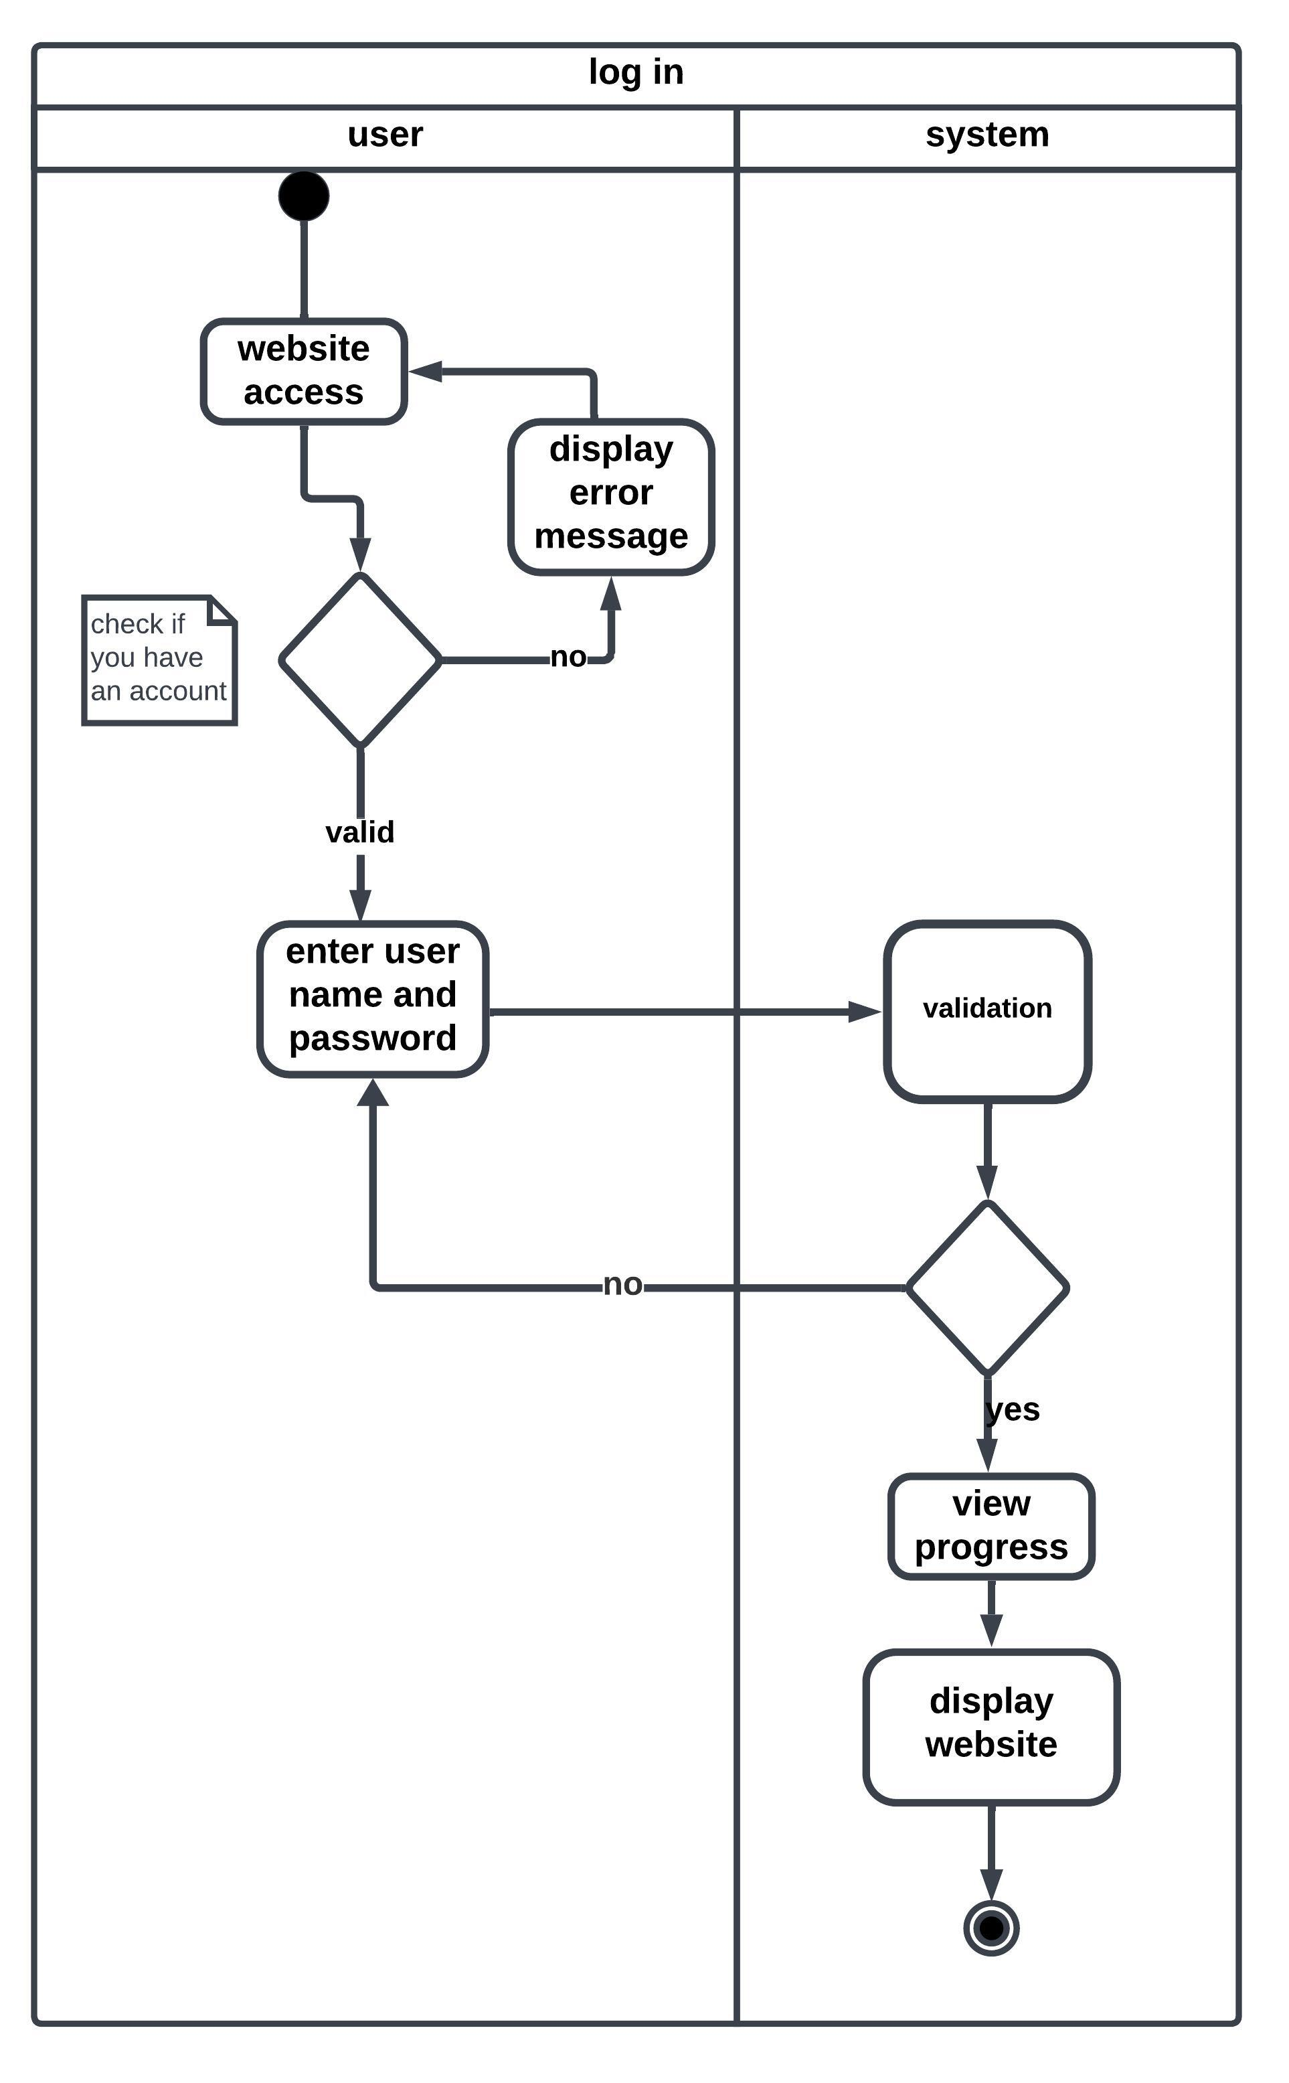
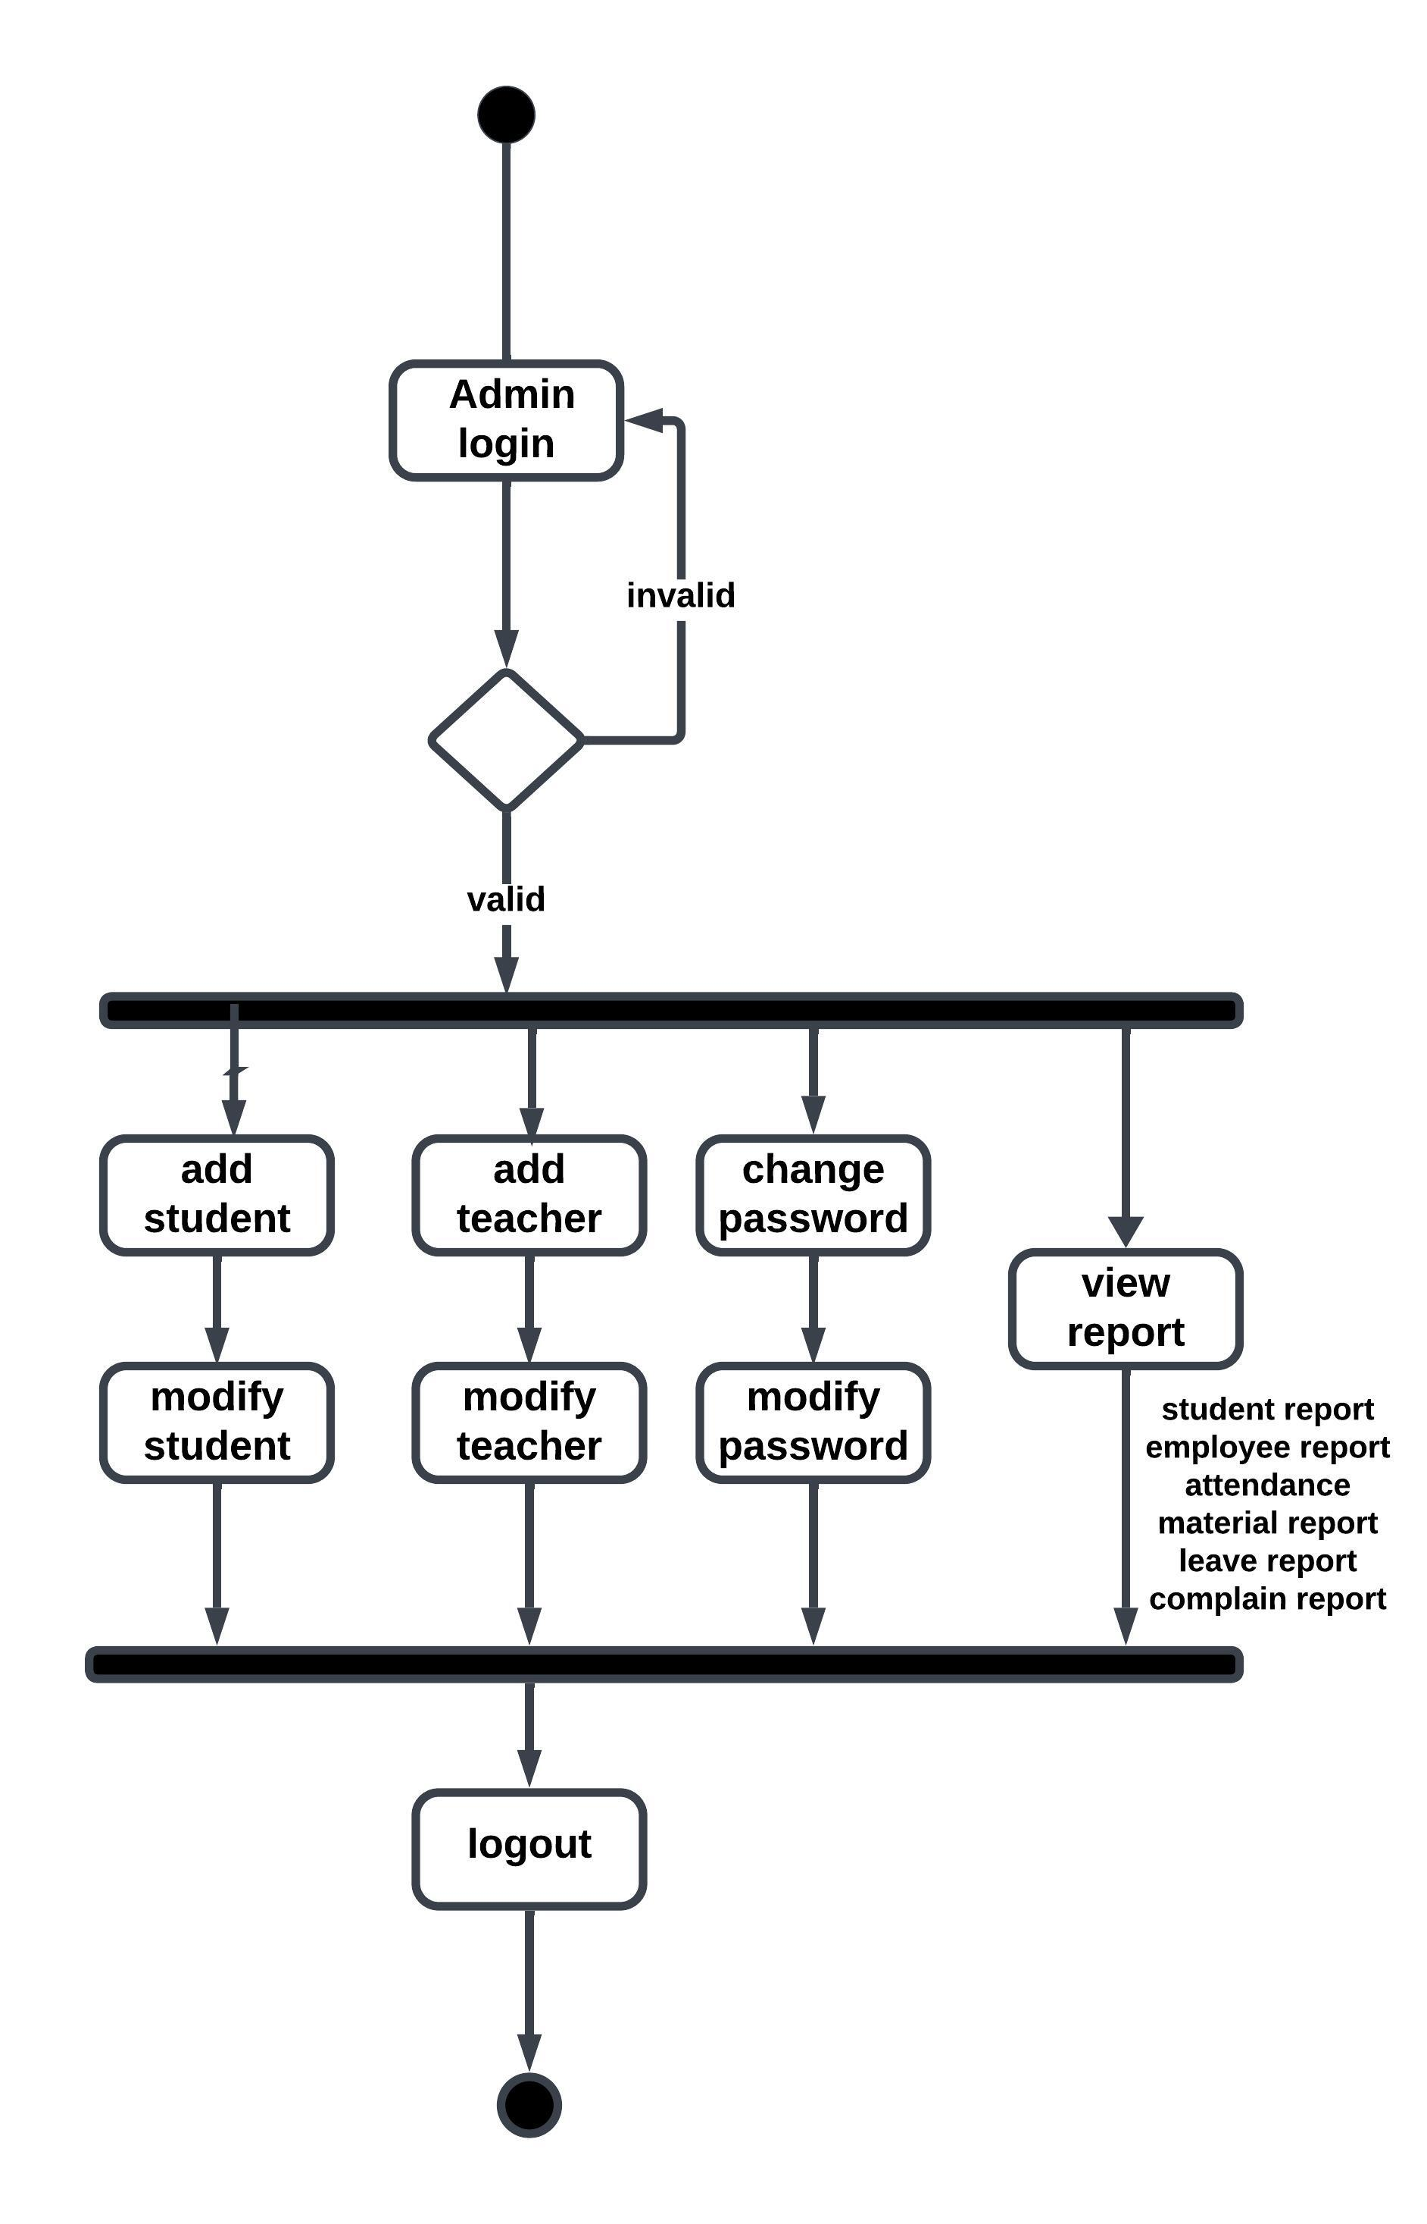
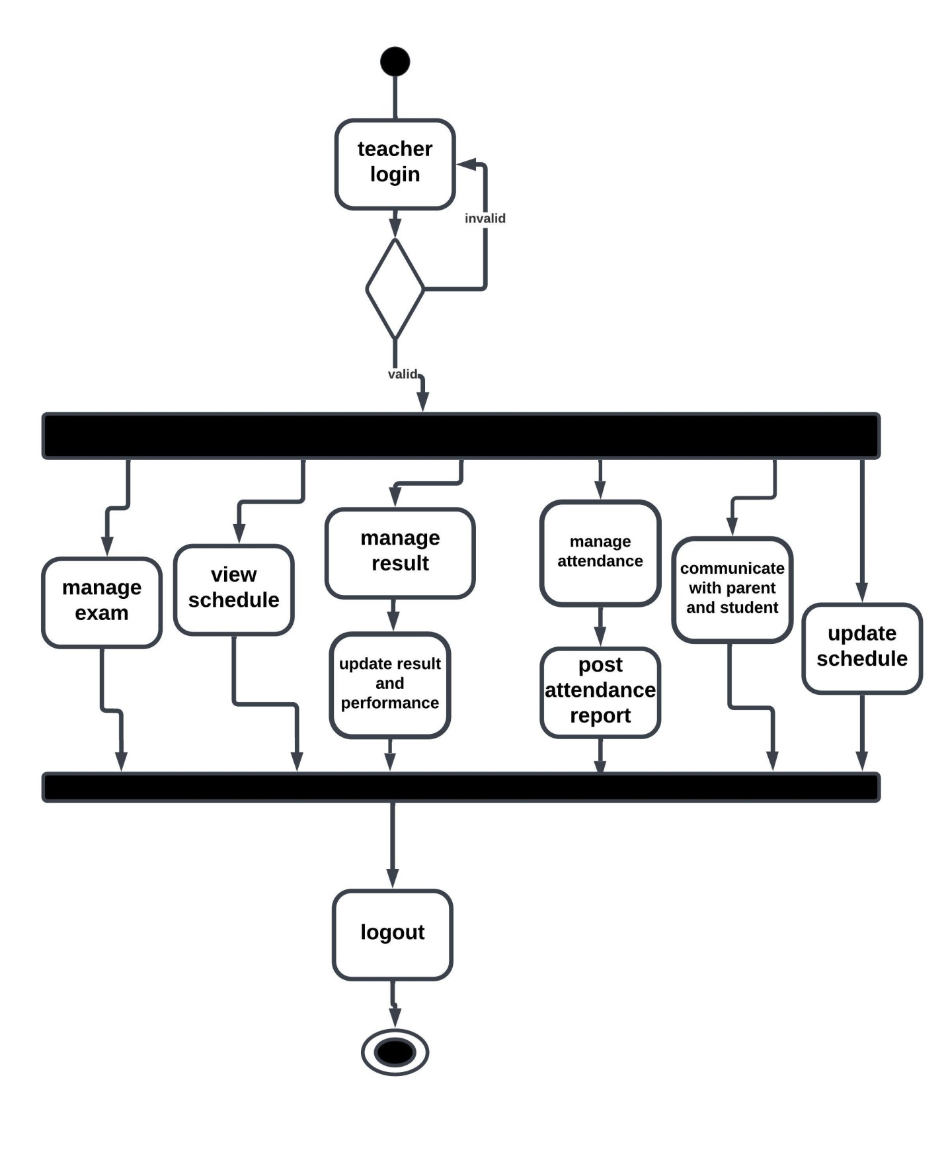
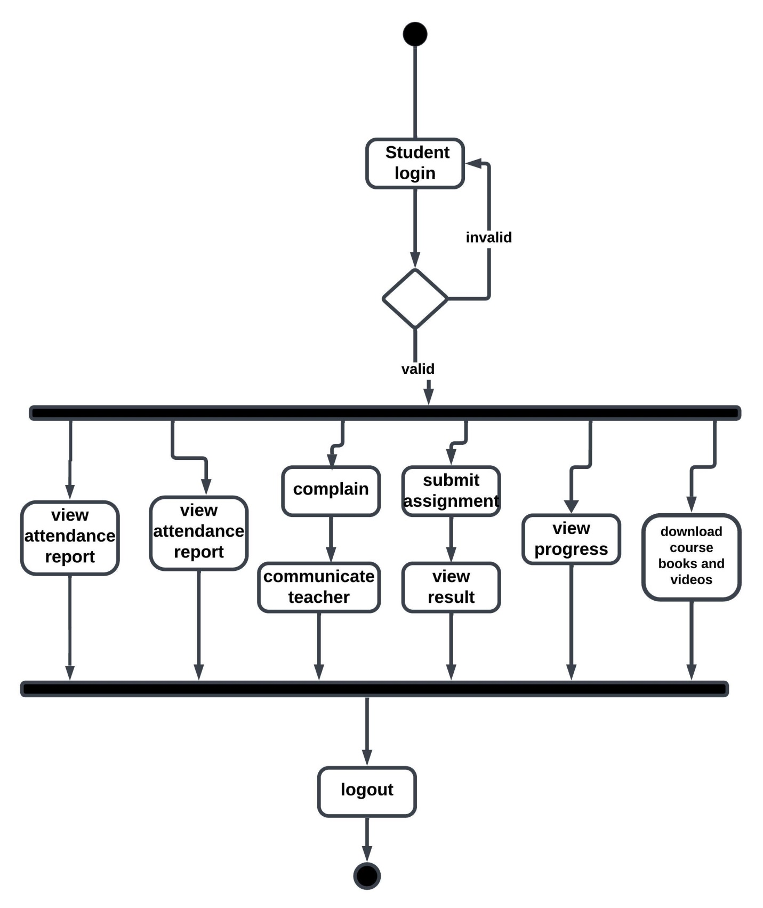
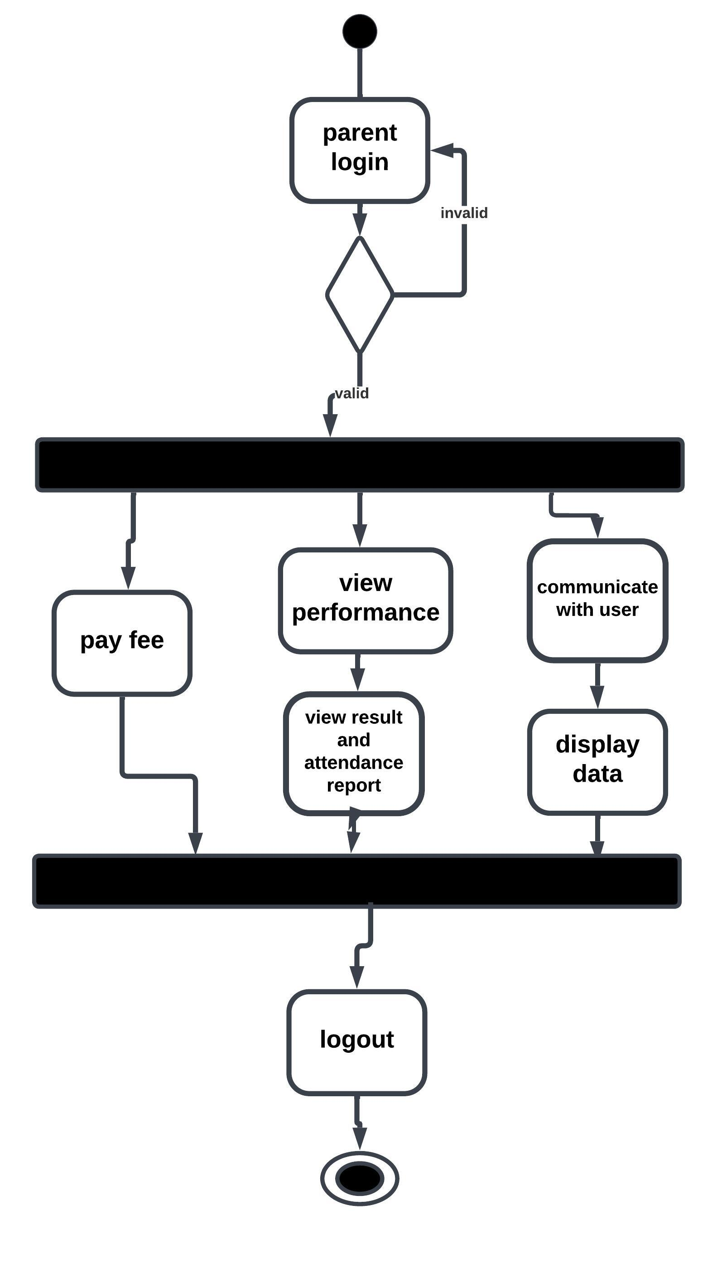
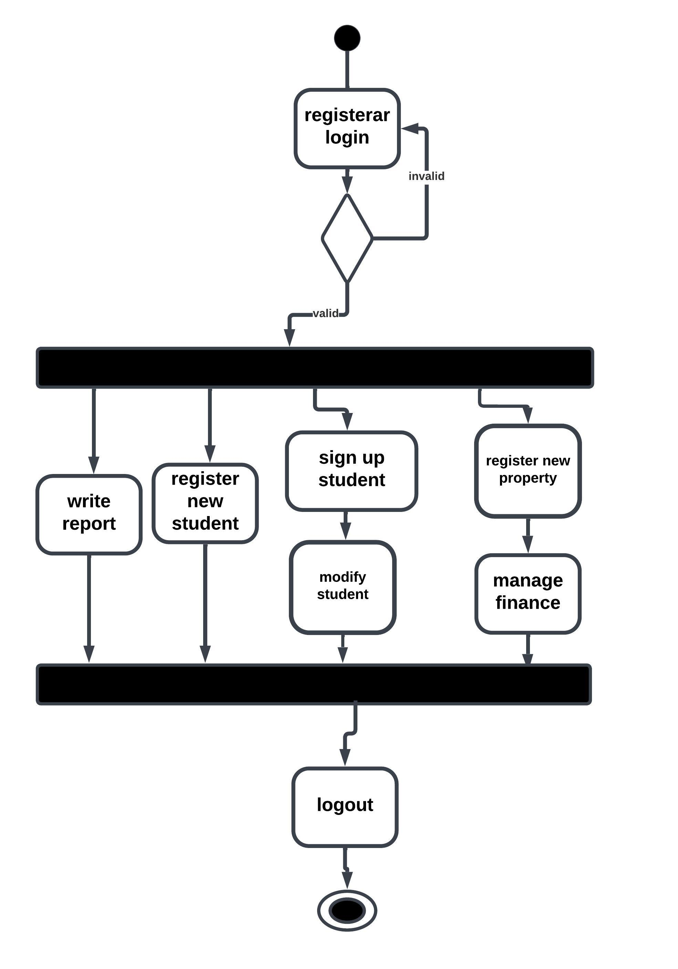
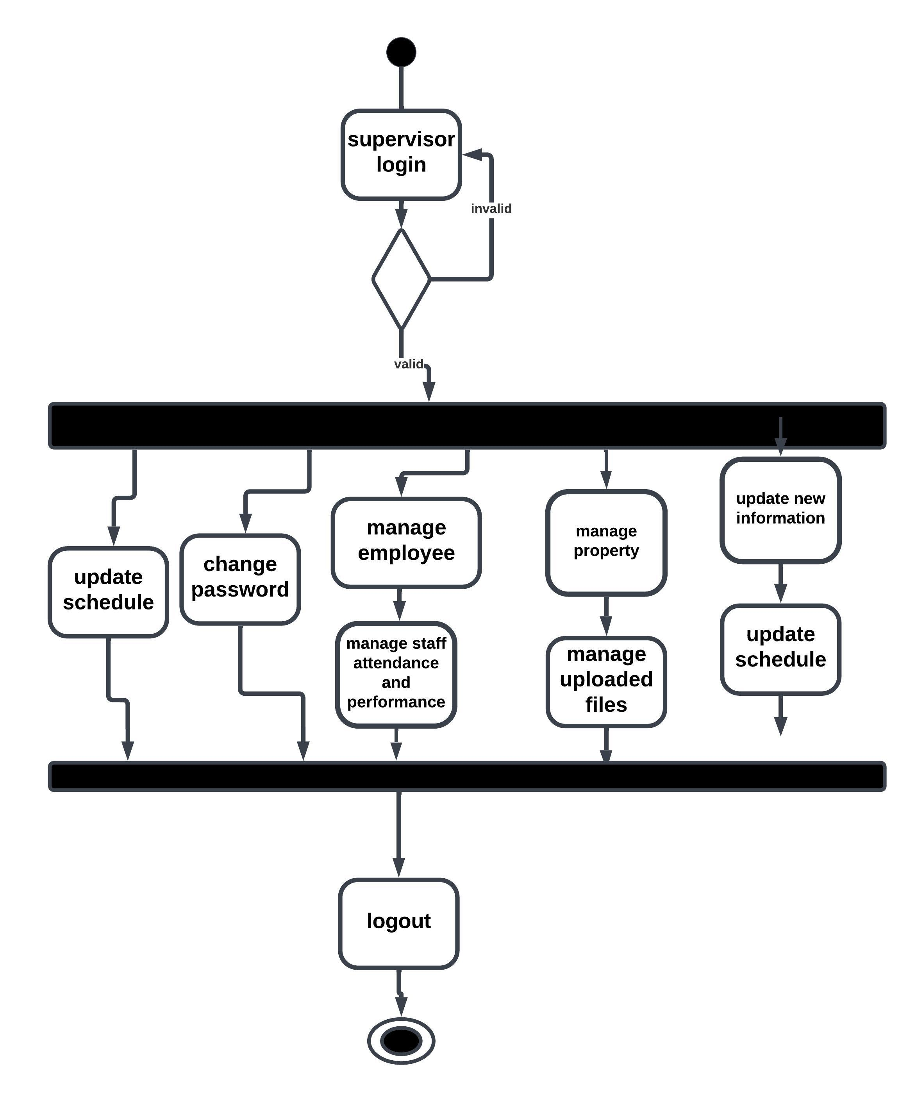
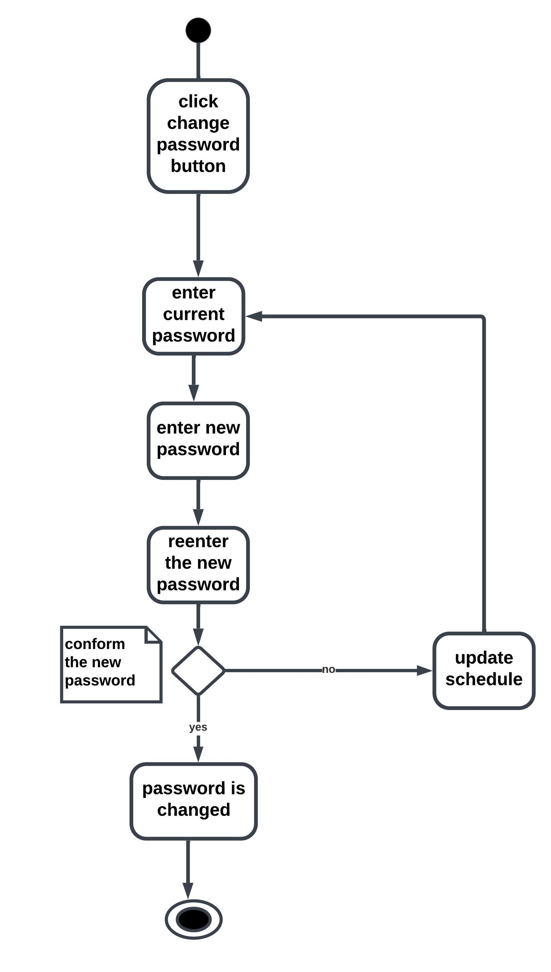
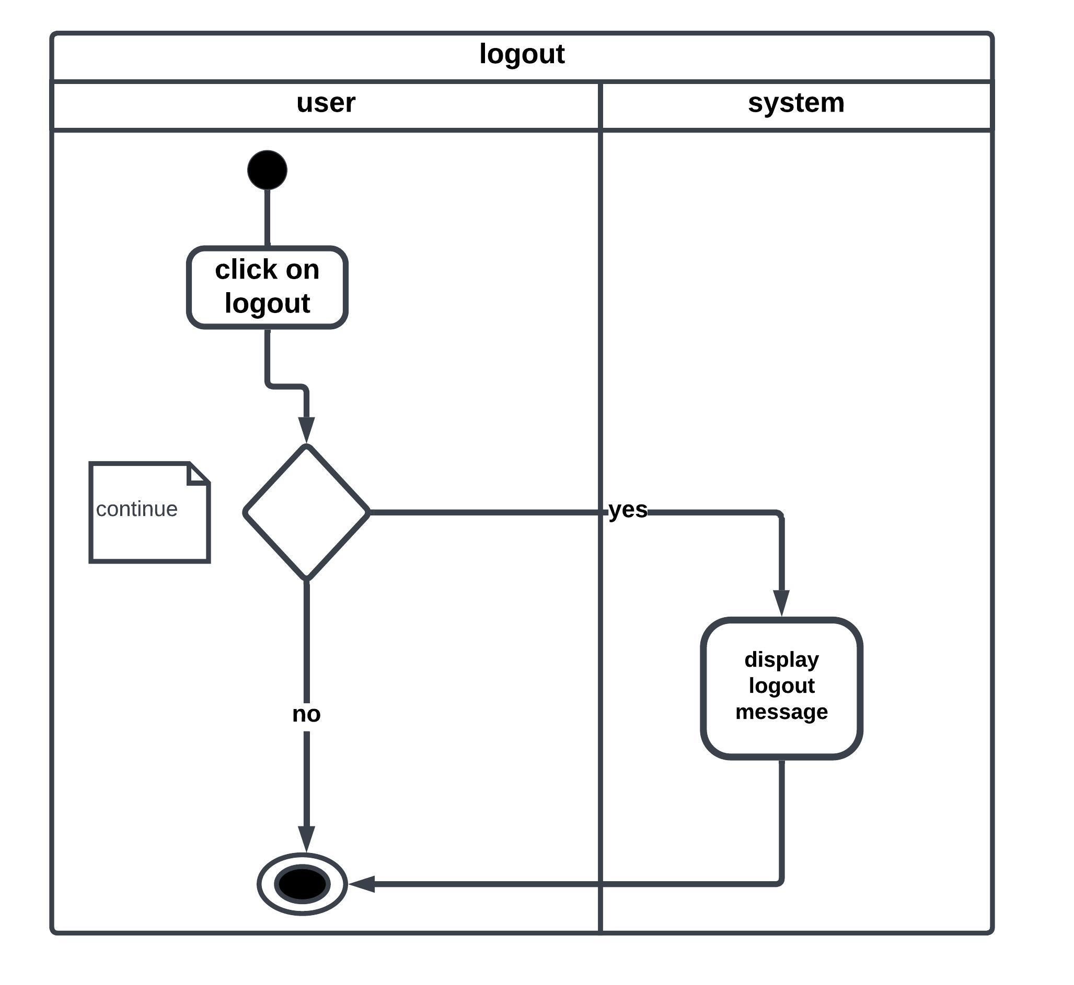
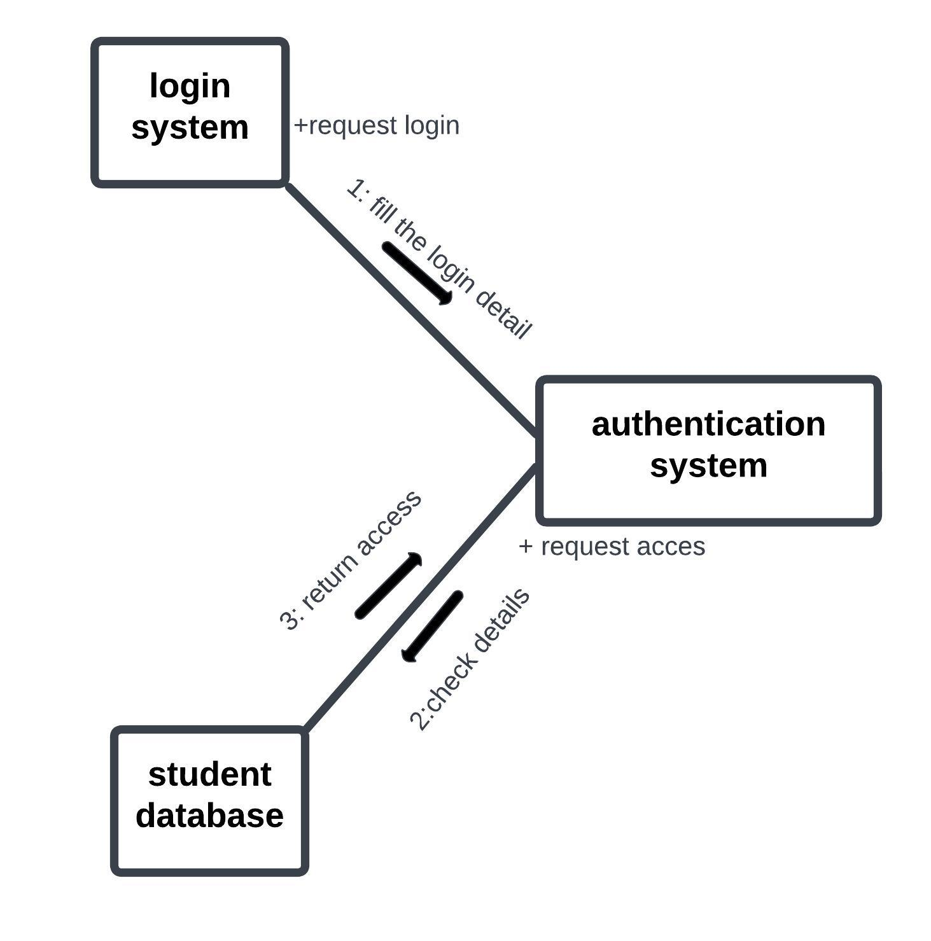
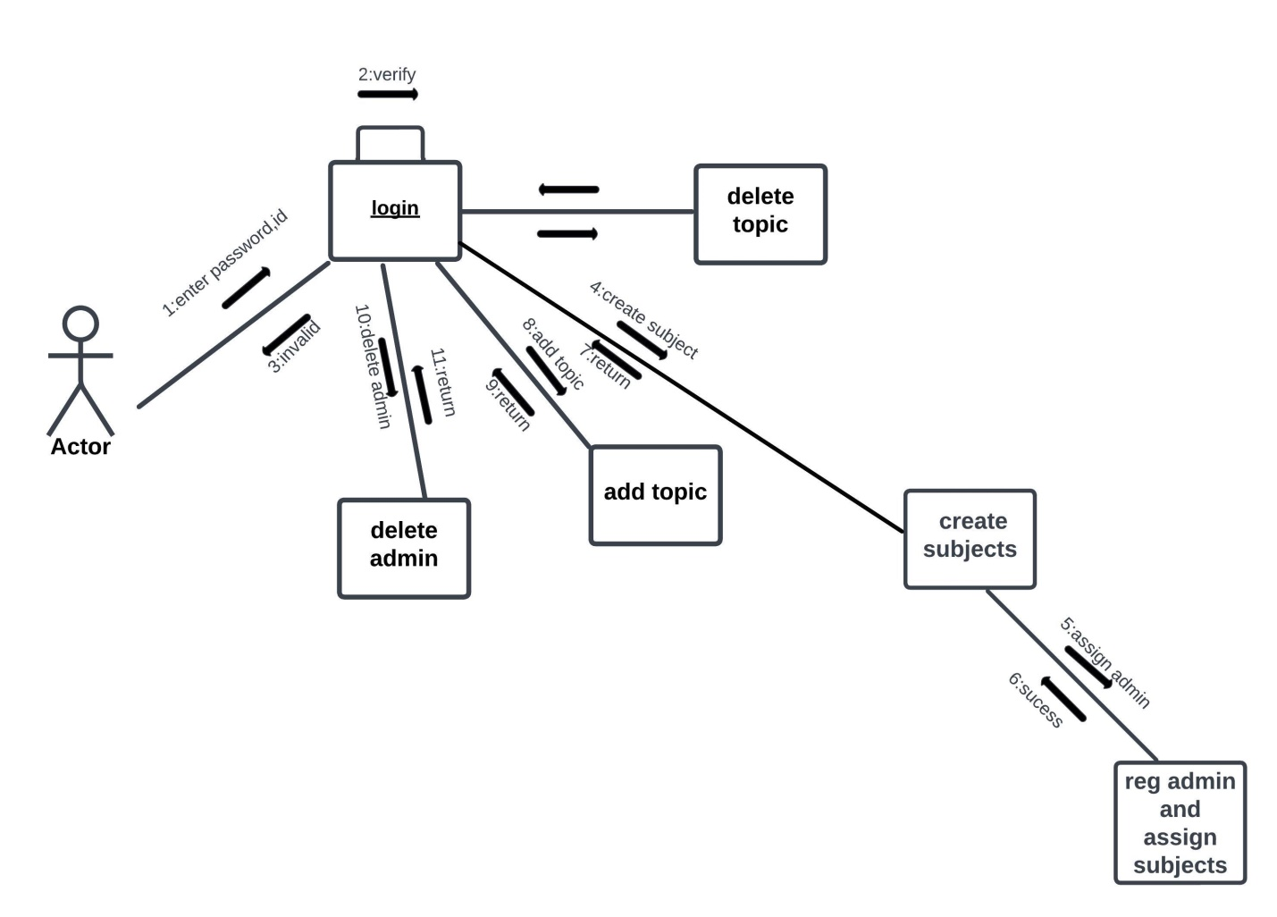
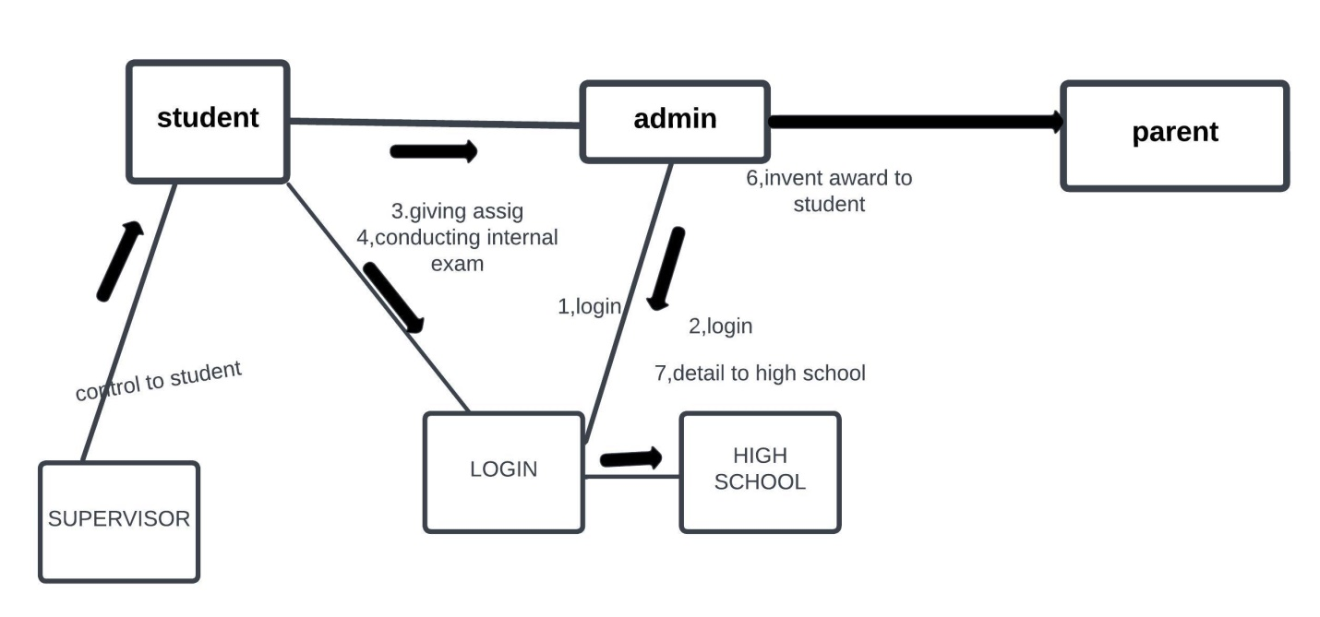
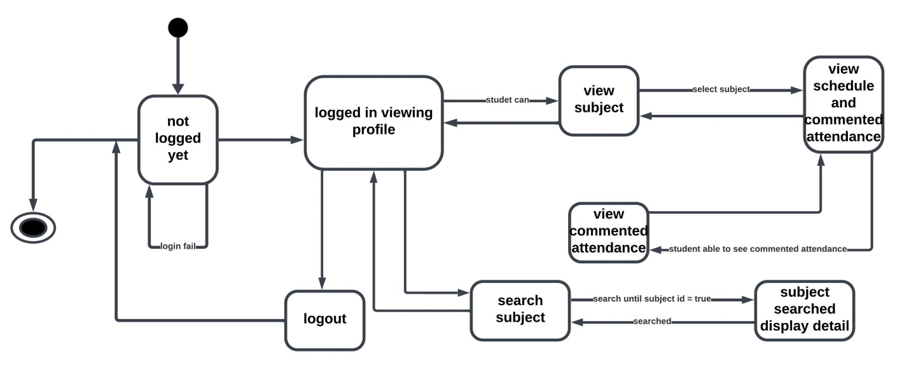
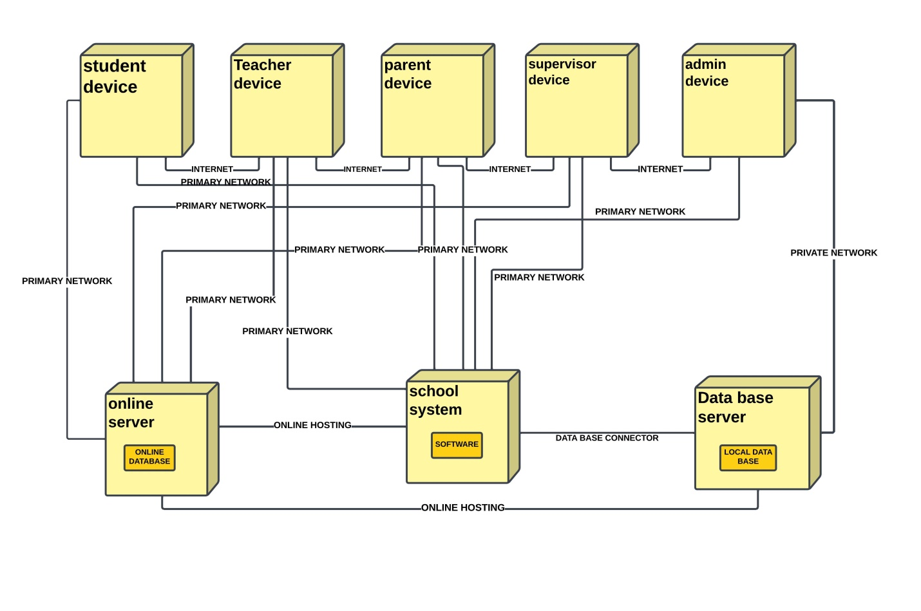
Contents
School administration software 4
1.Chapter one 4
1.1INTRODUCTION 4
1.2Statement of the problem 6
1.3OBJECTIVE 6
1.3.1 General 6
1.3.2Specific 6
1.4Scope of the software 7
1.5Software development approach 9
1.6Feasibility study 9
1.7Software model 9
1.8System requirements 9
2.Chapter 2 10
2.1Study of Existing system 10
2.2Use case of existing system 11
2.3 Use case scenarios exiting system 12
3.Chapter 3 14
3.1Proposed system 14
3.2Requirements 15
3.3Use case 15
3.4Use case description 16
3.5Use case diagram 19
3.6Usecase scenario of proposed system 19
3.7Class diagram 23
3.8Sequence diagram 24
3.9Activity diagram 29
3.10 Collaboration diagram 41
3.11 state diagram 43
3.12Deployment diagram 44

Project 1

School administration software

Chapter one

INTRODUCTION
The foundation of a school or any educational institution is laid on a complicated network of interrelated tasks altogether regulated by a functional chain.
For managing the complex correlated tasks of school the school management system software acts as a bridge between the administrative members, parents, teachers, and students. This software is also an interactive site where the exchange of information, data, funds, or statistics is done.
The school management system represents an indispensable solution that can offer seamless integration to the institutions. A school or an institution conducts plenty of tasks or processes that require active monitoring or checking. For example, the tasks from different ends are mentioned below:
- Students- Student-related tasks involve managing exam fees, certificates, roll numbers, report cards, etc.
- Teachers- Teacher-related tasks involve creating or managing exam papers, parent-teacher meeting reports, payroll, time table, etc.
- Finance-From the finance end, there are term fees, exam fees, library fees, canteen fees, etc.
- Inventory-The inventory-related tasks include keeping a check on the library, reports, canteen, charts, laboratory, etc.
The school management system refers to a systematic approach to organizing the complex tasks of schools. The software is specially designed to manage and automate the operations and the management process of the schools along with conducting paperless administration.
It prevents institutions from wasting time on operational tasks and eliminates potential errors as well. There are several reasons for which institutions require well-versed school management software. The major ones are listed below-
- Smooth Communication
- Build Branding
- Online Payment and Fee Management
- Improves Productivity
- Transparency and Student Management
- Inventory Management

1. Smooth Communication
The school management system facilitates transparent and faster communication between the authorities and the involved persons of a school.
It also maintains the communication channel among teachers, students, parents, and other departments in a convenient manner. For example, schools can notify guardians or parents about a student’s performance, fees, report card, examination dates, etc.
2. Build Branding
The educational institutes will remain underrated in absence of any school management software development solution. The institutions which are technically updated or have an integration of advanced custom web development solutions will have a positive impact on parents, teachers, and most importantly, students. Ultimately this impression helps institutions to build strong school branding.
3. Online Payment and Fee Management
Many issues and quarrels have been reported in schools or educational institutions regarding in competencies from either party about fee management.
It is because collecting and managing the fee record of every student is an intense aspect of schools, and most importantly for large organizations.
The platforms that can integrate the school management software within their organization can leverage this technology for effectively maintaining fee records.
This software automatically generates receipts of payment for the reference of the sender as well as the receiver once the payment is made. In this manner, schools can easily keep track of free records with absolute convenience.
4. Improves Productivity
In a traditional setup, teachers are often seen engaging with various tasks other than teaching. An integration of sought-after school management systems will allow them to easily manage tasks.
Most importantly it eliminates the need for managing a task manually and teachers can rely on technology for carrying out a number of tasks. The school management software is a major element to assure productivity in schools.
5. Transparency and Student Management
With the help of a school management system, educational institutions can strengthen transparent conduct with their actions. For instance, if parents are occupied and cannot attend school meetings then they can check the student portal directly.
Similarly, the institution can also keep a close check on their students’ performance and track their records. The student-related data is inclusive of performance, attendance, admission, extracurricular activities, school projects, etc.
6. Inventory Management
Educational institutions are most often burdened with inventory management where they have to manage stationery, library, school furniture, sports equipment, etc.
With the assistance of a mobile app development company, educational institutions can have a reliable solution for managing inventory. With this solution, they can keep a close track of their types of equipment or books.
There are many school management systems available in the market. Some of the most popular ones include:
- Cleves's platform
- Kissflow School Cloud
- The Follett Destiny Resource Manager
- Vidyalaya School Software
- Gradelink

Statement of the problem
People in this country now strive to work hard and support their families, yet many neglect to pay their energy bills and children's school fees in the process. They even go so far as to claim, "I don't have time to go all the way to school to pay." Because the receipts are mostly manual, it may occasionally be misplaced, destroyed, or even devoured by a rat. Many parents have complained to the staff about this, and it can be challenging for schools to determine annual revenue without the receipt.
These days there has been a modification on paying fees. Banks have built a system to manage and control financial system of the school. This was a great idea you can pay by going directly to the bank or by using the bank’s software platform. But however the access is bounded in one bank only which means in order to use this access you must have an account of that bank.
Many teachers don't interact with parents, and many parents are unaware of how their child's academic career is proceeding. Due to this, a lot of parents are shocked by the outcome on the last day. This issue is also evident in school boards, as the majority of them are unaware of the basic necessities the school requires, such as a blackboard, desk, library books, etc. Overall, we can conclude that there are management issues in schools.
Students struggle because there aren't enough resources available for their education due to the lack of book publishers. Additionally, libraries don't have enough books to meet student demand. and as a result, we observe many struggling students.

OBJECTIVE

1.3.1 General
The objective of the system is to create technology based school management system teaching and learning process by making school services much simpler and more dependable. Generally the system the objective in increasing parental involvement in their children's affairs, managing properties and employees more effectively, and saving time, energy, and money.

1.3.2Specific
when we classify these objectives based on the users
Parents
- increasing their involvement in their child’s school performance.
- saving wastage of time and energy in school process.
- to have a better communication between parent and teacher ..
teacher
- saving energy by reducing the paper work
- making monitoring students much easier
- having a good communication with student and teacher
supervisor
- making employee and property management easier

registrar
- Making the student registration free from paper work
- Making paying fees free from paper work
- Reduce the loss of documentation
Administrator
- Making the management property and employee easier
- To make the flow of information faster

Scope of the software
It is the specific requirements and functionalities of the schools management system may vary depending on the needs of the school or educational institution implementing it.
1. User Management: This feature allows the system administrator to create and manage user accounts for teachers, students, and parents/guardians. It includes functionalities such as account creation, password management, and user role assignment.
2. Student Information Management: Teachers can input and manage student information such as personal details (name, age, etc.), contact information (phone number, address, etc.), and academic records (grades, attendance, etc.). This feature provides a centralized database for storing and accessing student information.
3. Attendance Management: Teachers can record and manage student attendance on a daily basis. This includes functionalities such as marking attendance, tracking absences, and generating attendance reports.
4. Grade Management: Teachers can input and manage student grades for different subjects or courses. This feature allows teachers to easily record and calculate grades, track progress, and generate grade reports.
5. Assignment Management: Teachers can create and manage assignments, set deadlines, and receive submissions from students. This feature provides a platform for assigning tasks, tracking submissions, and providing feedback to students.
6. Communication: Students and parents can communicate with teachers through the system, either via messaging or email. This feature facilitates seamless communication between all stakeholders, allowing for easy collaboration and information exchange.
7. Performance Tracking: Teachers can generate reports on student performance, including overall grades, attendance records, and assignment scores. This feature helps teachers monitor student progress, identify areas of improvement, and provide personalized feedback.
8. Parent/Guardian Portal: Parents/guardians can log in to the system to access their child's information, check grades, communicate with teachers, and make online payments for school fees or other expenses. This feature provides parents/guardians with a convenient way to stay updated on their child's academic performance and engage with the school community.
9. Notifications: The system sends notifications to teachers, students, and parents/guardians about important updates, events, or deadlines. This feature ensures that all relevant parties are informed in a timely manner, reducing the chances of miscommunication or missed deadlines.
10. Reporting: The system generates reports for administrators on various aspects of school management, such as student performance, attendance trends, and assignment completion rates. This feature provides valuable insights and data for decision-making and evaluation purposes.
- Student registration
- Interaction of students, teachers and parents
- Parents involvement
- Paying fee
- Computing, Recording and reporting of student progress
- Property registration
- Computing employees progress
- Portable lectures
LIMITATIONS
- the software is dependent on the internet connection so in order to use you need internet connection.
- the software needs smart device to operate .
- in order to use the software you must first have valid credentials from the admin.

Software development approach
- The first software development approach was gathering information from people who have directly relation with this matter for example parents, teachers, students and some school employees, then we collected more information from other people which are not directly involved like people which has experience on these matters.
- The second approach was knowing how the previous software works if there is any and what are the flows of the previous system and what is needed to be corrected and what kind of new features should we add on the new system based on user requirements.
- The third approach was observing of users and their experience of the previous system it helps to have better understanding on what the users want and helps us decide which applications of the software to keep and which to change.

Feasibility study
This study will determine the impact of the software in the current system and helps to know why this software is necessary for the system. and this will determine if the proposed system is worthwhile.
The system we built first , the interface is well organized and this allows the user easily interact with the system and access information easily and efficiently with-out any difficulty. Also the system is secured because only users can get in using user name and password. Because there are many authorization types users have different roles on the software based on their place in the school. This allows one user not to interfere with another user also prohibits outside intruders.
Second, the software we will apply might seem a little expensive but based on the benefit of the software in material consumption reduction, error reduction, and decrease money wastage decrease peper work.

Software model
Because we aim to construct the system more quickly with little time spent on analysis and design also for efficient modelling and documenting, we used the Agile method, this method is best suited for our system because of following qualities:
- Agile is best suited to small/medium-sized systems
- Focus on the code rather than the design
- It allows for flexibility

System requirements
Hardware requirements |  | Software requirements
Requirement | specifications | Requirement
processor | Minimum 1GHz  Recommended 2GHz | Operating systems
Display resolution | 720*1280,1280*800, 768*1024, 1366*768, 1920*1080 | Database management system (DBMS)
RAM | 240Mb(phone)  Minimum 1GB  Recommended 2GB | Documentation tools
Storage | Minimum 8GB(phone)  Minimum 128 GB  recommended 256 GB | Web servers
Internet | Ethernet connection (LAN) or wireless adapter (wi-Fi) | -Frontend language  -Backend Language  -Code editor
 |  | Browsers

Chapter 2

Study of Existing system
The system we currently use is manual and semi manual, A manual school system is an educational system in which most administrative and educational responsibilities are conducted manually, without the use of advanced technology. This includes duties including controlling records, scheduling lessons, and communicating with parents, students, and teachers. In a manual education system, data is often written down and saved in physical files, and communication takes place in person or through written notes.

The process of enrolling a new student into the school by filling out forms and collecting documents. And the registrar has to manually enter the details of the students in to the files then put the files into the shelves.
The process of admitting students into specific classes or courses based on their eligibility and availability. The school staff has to manually check the student records, assign them to sections, and issue them admission slips or cards.
The process of managing the course, schedule, and assessment of the courses offered by the school. The school staff has to manually prepare and distribute the course materials, schedule the classes and exams, and grade the students' performance.
The process of evaluating the teachers' performance and feedback based on their teaching quality, attendance, and student satisfaction. The school staff has to manually conduct surveys, interviews, or observations and record the results in reports or files.
The process of communicating and collaborating with the stakeholders of the school, such as students, parents, teachers, and administrators. The school staff has to manually send or receive letters, notices, or messages and arrange meetings or events.
In semi manual system the process uses both the manual and some technology

Use case of existing system

Figure: use case of existing system

2.3 Use case scenarios exiting system
The use case scenarios for registration, uploading a file, viewing results, paying fees, property administration, and student performance checking in a manual school system:
1. Registration:
- Actors: Student,teacher, School Admin
- Pre-conditions: The school must have a registration form and the student must submit it to the school.
- Basic flow:
1. Student obtains the registration form from the school.
2. Student fills in the required details in the form.
3. Student submits the form to the registeral.
4. registeral verifies the details and approves the student's registration.
5. The registeral updates the student's record with the approved status.
2. Viewing results:
- Actors: Teacher, Student
- Pre-conditions: The teacher must have entered grades/feedback on paper and the student must have completed the term/semester.
- Basic flow:
1. Teacher enters grades/feedback on paper for each subject.
2. Teacher prepares a report card for each student.
3. School admin distributes the report cards to the students.
4. Student can view their grades/feedback on the report card.
4. Paying fees:
- Actors: Student, Accountant
- Pre-conditions: The school must have a fee structure and the student must pay the fees to the accountant.
- Basic flow:
1. School admin provides the fee structure to the student.
2. Student pays the fees to the accountant in cash or by check.
3. Accountant verifies the payment and updates the student's record with the paid status.
4. School admin provides a receipt to the student.
5. Property administration:
- Actors: School Admin, Maintenance Staff
- Pre-conditions: The school must have a property management plan and the maintenance staff must report any issues to the school admin.
- Basic flow:
1. Maintenance staff reports any issues with the school property to the school admin.
2. School admin assesses the issue and assigns the task to the maintenance staff.
3. Maintenance staff completes the task and reports back to the school admin.
4. School admin verifies the completion of the task and updates the property record.
6. Student performance checking:
- Actors: Parent, Teacher
- Pre-conditions: The teacher must have assessed the student's performance and provided feedback on paper, and the parent must check their child's performance.
- Basic flow:
1. Teacher assesses the student's performance and provides feedback on paper.
2. Teacher provides the feedback to the student's parent during parent-teacher meetings or through email or in person.
3. Parent checks their child's performance based on the feedback provided by the teacher.
This process can be time-consuming and prone to errors, such as typos or misplaced paperwork. It also requires students to physically visit the administrative office to complete registration, which can be inconvenient for those who live far away or have busy schedules.
An automated school management system, on the other hand, would allow students to register online and automatically update the class roster and schedule in real-time. Students could access the system from anywhere with an internet connection and complete registration quickly and easily. The system could also send automatic notifications to students if there are any changes to the course schedule, reducing the need for manual updates and improving efficiency. Additionally, an automated system would reduce the likelihood of errors, as data entry would be automated and standardized.

Chapter 3

Proposed system
The proposed system is a simple school managing system which is used in making every school activities easier and reliable. It changes the traditional manual system into digital and more advanced system. school activities like paying fee, property administration, student performance checking and other many activities took much time and energy but now with this software is can be done anywhere anytime The system is specially build for elementary and high schools. But not essentially for higher institutes because many higher education institutes have their own websites but still these institutes can use it too.
This software helps to make

Requirements
requirements
Functional requirements | Non functional requirements
Loging in | Review
profile | Comment
Registration | Receiving salary
Uploading files | complain
View schedule
View progress
Digital library
Fee paying
communication
View results
View attendance
Download files

Use case
 | Actors | Description
1. | Students | - Login  - View profile and progress  - Download course books and videos  - Submit assignment  - Communicate with teacher  - View schedule  - logout
2. | Teacher | - Login  - View profile  - Update result and progress  - Upload course videos and books  - Accept assignment  - Communicate with parent and student  - propose schedule  - Update attendance  - Logout
3. | Parent | - Login  - View profile  - View result and progress  - View schedule and attendance  - Pay fees  - Communicate with teacher  - Logout
4. | Supervisor | - Login  - View profile  - View students and employees attendance  - View schedule  - Review and upload schedule  - Change password  - Write a report  - logout
5. | Registral and finance | - Login  - View profile  - Registering new students  - Register properties  - Accepting fees  - Manage payment services  - Write report  - Logout
8. | President / Administrator | - Login  - View profile  - Enroll teacher  - Manage properties  - Remove student  - View student, teacher and all employees performance.  - Control every action  - Change password  - Review reports  - Logout

Use case description
Use case name | Description | Actors | Pre-condition | Main flow | Exceptional flow
Log in | Enter to the system | All actors | - Internet access  2 .Must have valid credential by the school | 1. Display the login page  2. Student fills name and password  3. checks weather the user name and password is correct  4. if it is correct the user gets assigned access to the system | If user fills invalid user name and password the system notifies to enter the correct user name and password
View profile | To see user profile | All actors | Must have internet access  Must login  Have valid credentials | 1. Students gets access to view course types  2. Users gets access to see new information’s  3. Students and teachers get to see schedules
Update result | To post result | Teachers  Supervisors  Administrators | Must have internet access  Must login  Must have valid credentials | 1,Actors get access to renew the result and grades of students  2. Actors get access to post result and grade to students
Update schedule |  | Teachers  Supervisors | Must have internet access  Must login  Must have valid credentials | Actors get access to renew class schedules
Submit assignment |  | students | Must have internet access  Must login  Must have valid credentials | Students get access to submit any type of assignment to the teacher
Pay fee |  | Parents | Must have internet access  Must login  Must have valid credentials | Actors get access to pay fees using the system
View schedule |  | Students  Parents  Supervisors | Must have internet access  Must login  Must have valid credentials | Actors will have access to see the schedule posted by the teacher or supervisor
Update attendance |  | Teachers  Supervisors | Must have internet access  Must login  Must have valid credentials | Teachers will have the access to update the attendance of students  Supervisors will have the access to
Give assignment |  | Teachers | Must have internet access  Must login  Must have valid credentials | Actors will have the access to give assignements to students
Property registration |  | Registrar | Must have internet access  Must login  Must have valid credentials | Actors will have the access to register new properties in to the system
Enrollment |  | Supervisor | Must have internet access  Must login  Must have valid credentials | Actors will have the access to add employees to the system
Upload files |  | Teacher  supervisors | Must have internet access  Must login  Must have valid credentials | Actors will have the access to upload audio ,video,  text, document, pdf files in to the system
Manage uploads |  | supervisor | Must have internet access  Must login  Must have valid credentials | Actors will have the access to delete anything that is uploaded system
Register students |  | Registrar | Must have internet access  Must login  Must have valid credentials | Actors will have the access to register and sign up new student in to the system
Write report |  | Teacher  Supervisor  Registrar  Librarian | Must have internet access  Must login  Must have valid credentials | Actors will have the access to evaluate their performance
Receiving salary |  | Teachers  Supervisor  Registrar | Must have internet access  Must login  Must have valid credentials | Actors will have the access to get notified if their salary is recieved

Use case diagram

Usecase scenario of proposed system
The use case scenarios for registration, uploading a file, paying fee,property administration, student checking performance and viewing results in the existing system:
1. Registration:
- Actors: Student, School Admin
- Pre-conditions: The school must have an account in the school management system and the registration form must be defined in the system.
- Basic flow:
1. Student navigates to the registration page of the school management system.
2. Student fills in the required details in the registration form.
3. The system verifies the details and sends a verification email to the student's email address.
4. Student clicks on the verification link in the email to complete the registration process.
5. School Admin receives a notification of the new registration and approves the student's account.
6. The system updates the student's record with the approved status.

2. Uploading a file:
- Actors: Teacher, Student
- Pre-conditions: The teacher must have assigned a file upload task to the student and the file upload module must be defined in the system.
- Basic flow:
1. Teacher assigns a file upload task to the student through the school management system.
2. Student logs in to the system and navigates to the file upload module.
3. Student selects the task and uploads the required file.
4. The system verifies the file format and size and updates the task status as "completed".
5. Teacher receives a notification of the completed task and reviews the uploaded file.

3. Viewing results:
- Actors: Teacher, Student
- Pre-conditions: The teacher must have entered grades/feedback in the system and the student must have completed the term/semester.
- Basic flow:
1. Student logs in to the school management system.
2. Student selects the option to view performance.
3. The system displays the student's grades/feedback for each subject.
4. Student can view detailed performance reports and compare with previous terms/years.
5. Teacher can update the grades/feedback in the system and the system updates the student's record accordingly.
4. Paying fee:
- Actors: Student, parent and registerar
- Pre-conditions: Student must have an account in the school management system and the fee structure must be defined in the system.
- Basic flow:
1. Student logs in to the school management system.
2. Student selects the option to pay the fee.
3. The system displays the fee structure and the amount due.
4. Student selects the payment method (online or offline).
5. If online, the student enters the payment details and confirms the payment. If offline, the student generates a payment voucher and submits it to the accountant.
6. The system updates the student's record with the payment details.
7. The accountant verifies the payment and updates the financial records.
5. Property administration:
- Actors: Property Manager, Maintenance Staff
- Pre-conditions: Properties must be defined in the school management system and maintenance schedules must be set up.
- Basic flow:
1. Property Manager logs in to the school management system.
2. Property Manager selects the property to be managed.
3. The system displays the property details and maintenance schedule.
4. Property Manager assigns maintenance tasks to the maintenance staff.
5. Maintenance Staff receives notification of assigned tasks and updates the system when tasks are completed.
6. The system updates the maintenance history and alerts Property Manager of any overdue tasks.

6. Student performance checking:
- Actors: Teacher, Student
- Pre-conditions: Student must have an account in the school management system and teacher must have entered grades/feedback in the system.
- Basic flow:
1. Student logs in to the school management system.
2. Student selects the option to view performance.
3. The system displays the student's grades/feedback for each subject.
4. Student can view detailed performance reports and compare with previous terms/years.
5. Teacher can update the grades/feedback in the system and the system updates the student's record accordingly.

Class diagram

Sequence diagram

FIGURE : SEQUENCE DIAGRAM FOR LOGING IN

SEQUENCE DIAGRAM FOR REGISTRATION

SEQUENCE DIAGRAM FOR UPLOADING FILE

SEQUENCE DIAGRAME FOR SUBMIT ASSIGNMET

SEQUENCE DIAGRAM FOR MANAGING

OVER ALL SEQUENCE DIAGRAM

Activity diagram

Collaboration diagram
FIGURE:LOGIN STATE DIAGRAM
FIGURE:ADMIN STATE DIAGRAM
:

state diagram

Deployment diagram

FIGURE: DEPLOYMENT DIAGRAM OF THE SYSTEM

